Unit 1: Solution of Non-Linear Equations

Prepared By: Er. Rubi Kumari Mahato

  - Errors and Accuracy in Numerical Computations
In numerical analysis, we rarely get "exact" answers. We aim for results within a tolerated error.
- Absolute Error: $E_{a}=∣\text{Approximate Value}-\text{True Value}∣$
- Relative Error: $E_{r}=\frac{\text{Absolute Error}}{∣\text{True Value}∣}$
- Percentage Error: $E_{p}=E_{r}×100$
- Significant Digits: Digits that carry meaning contributing to its precision.
- Rounding vs. Truncation:
  - Rounding: $π=3.1416$ (to 4 decimal places).
  - Truncation: $π=3.1415$ (cutting off without rounding).
Accuracy vs. Precision
- Accuracy: How close a value is to the true value
- Precision: How consistent repeated measurements are
Stopping Criteria for Iterations
- Stopping Criteria: We stop iterating when two successive approximations agree within a specified tolerance (e.g., $∣x_{n+1}-x_{n}∣<ε$) or when the function value is nearly zero ($∣f(x_{n})∣<ε$).
- Precision Requirements: Problems in the PDF specifically ask for corrections "up to 8 decimal places", "3 decimal places", etc.
Simply, iterations stop when:
- $∣x_{n+1}-x_{n}∣<ε$ (tolerance)
- $∣f(x_{n})∣<ε$ (function near zero)
- Maximum iterations reached

  - Bisection Method
Also known as the Bolzano method. It works on the Intermediate Value Theorem:
If $f(x)$ is continuous on $\left[a , b\right]$ and $f(a)⋅f(b)<0$, then there exists at least one root between $a$ and $b$.
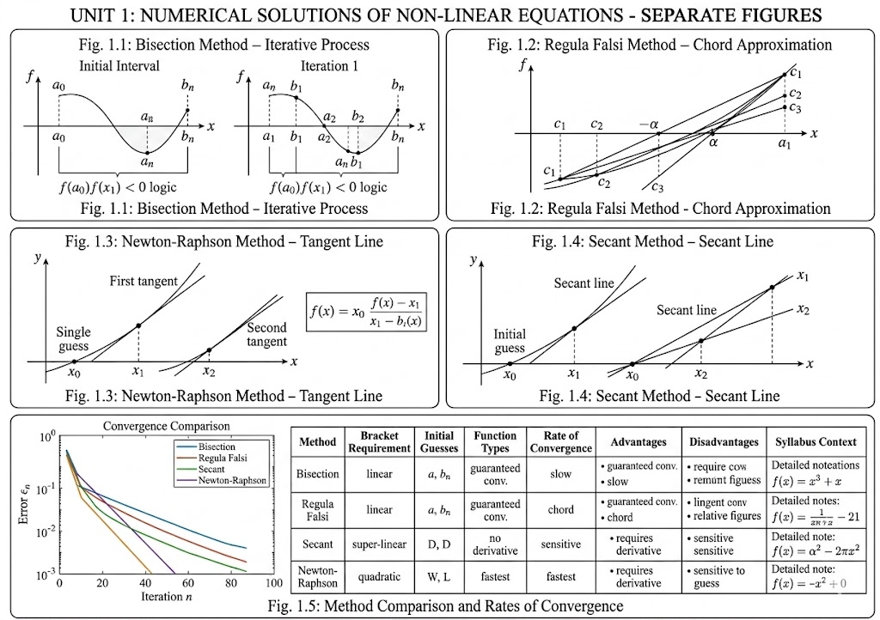
Figure 1.1. illustration of Bisection Methd

Algorithm
- Choose $a$ and $b$ such that $f(a)⋅f(b)<0$
- Compute midpoint $c=\frac{a+b}{2}$
- If $f(c)=0$, $c$ is the root
- If $f(a)⋅f(c)<0$, set $b=c$; else set $a=c$
- Repeat until $∣b-a∣<ε$
Formula
$$c=\frac{a+b}{2}$$
Characteristics
- Pros: Always converges, simple to implement
- Cons: Slow convergence (linear rate)
- Best for: Finding rough root location

Problem: Find a root of $x^{2}-4x-10=0$ correct to 2 decimal places using Bisection Method.
Solution:
$$f(x)=x^{2}-4x-10$$$f(5)=25-20-10=-5$ (Negative)
$f(6)=36-24-10=2$ (Positive)
Root lies between 5 and 6.
Iteration 1: $x_{1}=\frac{5+6}{2}=5.5$, $f(5.5)=-1.75$ → Root in [5.5, 6]
Iteration 2: $x_{2}=\frac{5.5+6}{2}=5.75$, $f(5.75)=0.0625$ → Root in [5.5, 5.75]
Proceeding similarly yields Root ≈ 5.74

Python Code:
# Bisection Method
import math

def bisection(f, a, b, tol=1e-6, max_iter=100):
"""
Find root using Bisection Method

Parameters:
f: function
a, b: interval [a, b] containing root
tol: tolerance
max_iter: maximum iterations
"""
if f(a) * f(b) > 0:
print("Root not bracketed. Choose different a and b.")
return None

print("\n" + "="*60)
print("BISECTION METHOD")
print("="*60)
print(f"{'Iter':<6}{'a':<12}{'b':<12}{'c':<12}{'f(c)':<12}")
print("-"*60)

for i in range(max_iter):
c = (a + b) / 2
fc = f(c)

print(f"{i+1:<6}{a:<12.6f}{b:<12.6f}{c:<12.6f}{fc:<12.6f}")

if abs(fc) < tol or abs(b - a) / 2 < tol:
print("-"*60)
print(f"Root: {c:.6f}")
Output
print(f"Iterations: {i+1}")
return c

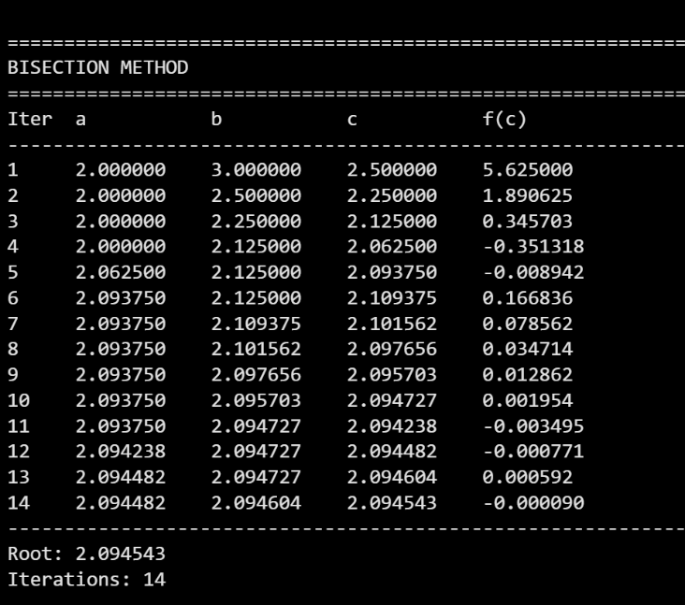
if f(a) * fc < 0:
b = c
else:
a = c

print("Method did not converge")
return None

# Example usage
if __name__ == "__main__":
f = lambda x: x**3 - 2*x - 5
bisection(f, 2, 3, tol=1e-4)

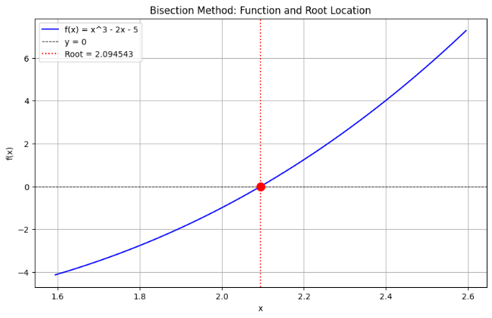
Figure: Visualization of bisection method of above function using Python code

  - Regula Falsi Method (False Position)
Improves upon bisection by interpolating between two points instead of just halving.
Principle
Uses a straight line between two points on the curve. The intersection of this line with the x-axis gives the next approximation.
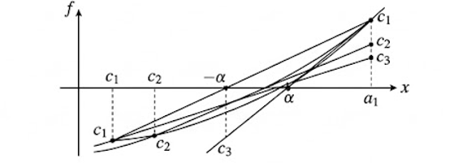
Figure 1.2. illustration of Regula Falsi Method

Formula
$$x_{new}=x_{1}-\frac{f(x_{1})⋅(x_{2}-x_{1})}{f(x_{2})-f(x_{1})}$$
Algorithm
- Choose $x_{1}$ and $x_{2}$ with $f(x_{1})⋅f(x_{2})<0$
- Compute $x_{new}$ using the formula
- If $f(x_{new})=0$, stop
- If $f(x_{1})⋅f(x_{new})<0$, set $x_{2}=x_{new}$; else set $x_{1}=x_{new}$
- Repeat until $∣x_{2}-x_{1}∣<ε$
Characteristics
- Faster than bisection for linear-like functions
- May converge from only one side
- Not suitable for multiple roots

Python Code:
# Regula Falsi Method
import math

def regula_falsi(f, a, b, tol=1e-6, max_iter=100):
"""
Find root using Regula Falsi Method

Parameters:
f: function
a, b: interval [a, b] containing root
tol: tolerance
max_iter: maximum iterations
"""
if f(a) * f(b) > 0:
print("Root not bracketed. Choose different a and b.")
return None

print("\n" + "="*60)
print("REGULA FALSI METHOD")
print("="*60)
print(f"{'Iter':<6}{'a':<12}{'b':<12}{'c':<12}{'f(c)':<12}")
print("-"*60)

for i in range(max_iter):
c = b - f(b) * (b - a) / (f(b) - f(a))
fc = f(c)

print(f"{i+1:<6}{a:<12.6f}{b:<12.6f}{c:<12.6f}{fc:<12.6f}")

if abs(fc) < tol or abs(b - a) < tol:
print("-"*60)
print(f"Root: {c:.6f}")
Output
print(f"Iterations: {i+1}")
return c

if f(a) * fc < 0:
b = c
else:
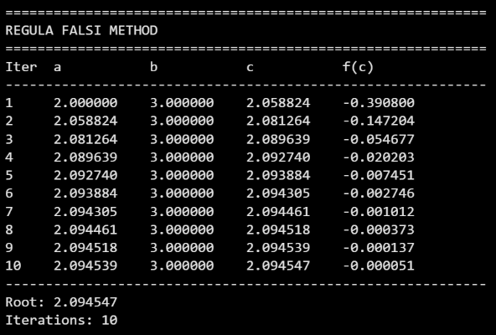
a = c

print("Method did not converge")
return None

# Example usage
if __name__ == "__main__":
f = lambda x: x**3 - 2*x - 5
regula_falsi(f, 2, 3, tol=1e-4)
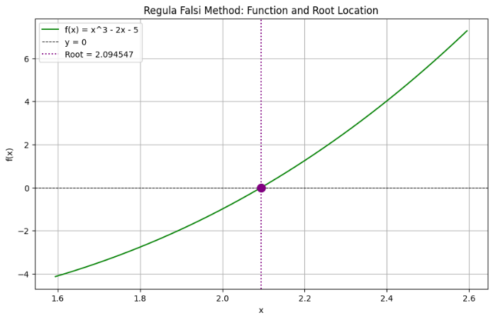
Figure: Visualization of Falsi method of above function and root location

  - Secant Method
The Secant Method is an open method for finding roots of non-linear equations. It approximates the derivative in Newton-Raphson method using a finite difference approach, thus avoiding the need to compute $f^{'}(x)$ explicitly
Principle
Similar to Regula Falsi, but does not require bracketing of the root. Uses two initial guesses that need not enclose the root.
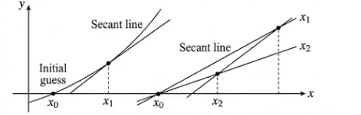
Figure 1.3. illustration of Secant Method

Formula
$$x_{new}=x_{2}-\frac{f(x_{2})⋅(x_{2}-x_{1})}{f(x_{2})-f(x_{1})}$$
Algorithm
- Choose two initial guesses $x_{0}$ and $x_{1}$ (no sign condition needed)
- Compute $x_{2}$ using the formula
- Replace $\left(x_{0} , x_{1}\right)$ with $\left(x_{1} , x_{2}\right)$
- Repeat until convergence
- Comparison with Regula Falsi
Feature | Regula Falsi | Secant
Requires bracket | Yes | No
Guaranteed convergence | Yes | No
Speed | Slower | Faster

Python Code:
# Secant Method
import math

def secant(f, x0, x1, tol=1e-6, max_iter=100):
"""
Find root using Secant Method

Parameters:
f: function
x0, x1: initial guesses
tol: tolerance
max_iter: maximum iterations
"""
print("\n" + "="*60)
print("SECANT METHOD")
print("="*60)
print(f"{'Iter':<6}{'x_{n-1}':<14}{'x_n':<14}{'x_{n+1}':<14}{'f(x_{n+1})':<14}")
print("-"*60)

for i in range(max_iter):
f0 = f(x0)
f1 = f(x1)

if abs(f1 - f0) < 1e-12:
Output
print("Division by zero")
return None

x2 = x1 - f1 * (x1 - x0) / (f1 - f0)
f2 = f(x2)

print(f"{i+1:<6}{x0:<14.6f}{x1:<14.6f}{x2:<14.6f}{f2:<14.6f}")

if abs(f2) < tol or abs(x2 - x1) < tol:
print("-"*60)
print(f"Root: {x2:.6f}")
print(f"Iterations: {i+1}")
return x2

x0, x1 = x1, x2

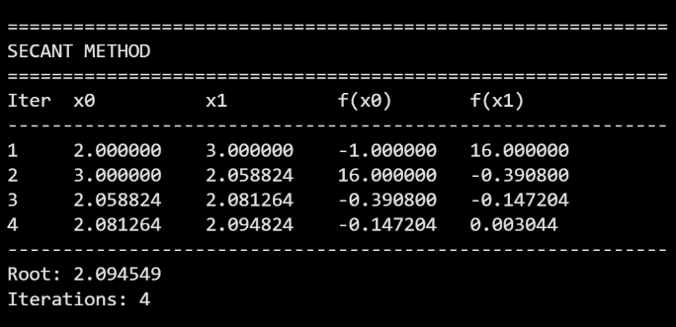
print("Method did not converge")
return None

# Example usage
if __name__ == "__main__":
f = lambda x: x**3 - 2*x - 5
secant(f, 2, 3, tol=1e-6)
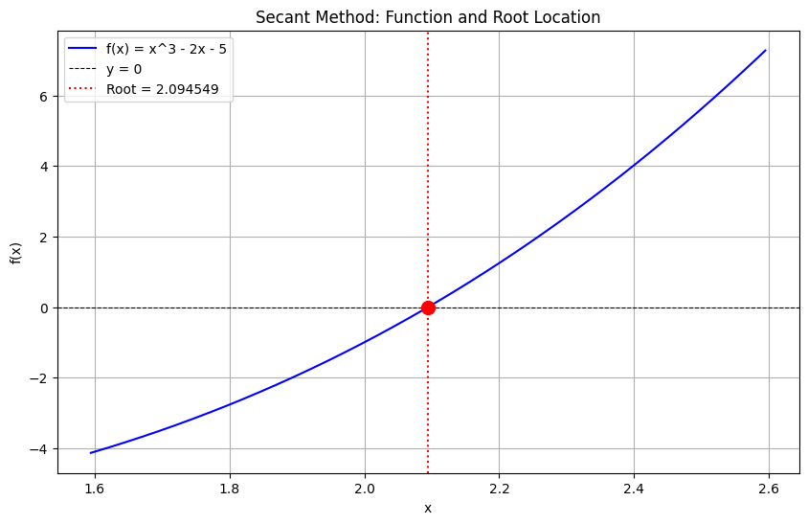
Figure: Visualization of Secant method of above function and root location
1.5 Newton-Raphson Method
Principle
Uses the tangent line at a point to approximate the root. Each iteration improves the estimate.
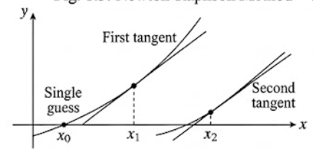
Figure 1.2. illustration of Newton-Raphson Method

Formula
$$x_{n+1}=x_{n}-\frac{f(x_{n})}{f^{'}(x_{n})},f^{'}(x_{n})≠0$$
Derivation (Tangent Line)
Equation of tangent at $\left(x_{n},f(x_{n})\right)$:
$$y-f(x_{n})=f^{'}(x_{n})(x-x_{n})$$
Set $y=0$ and solve for $x$:
$$0-f(x_{n})=f^{'}(x_{n})(x_{n+1}-x_{n}) \\ x_{n+1}=x_{n}-\frac{f(x_{n})}{f^{'}(x_{n})}$$
Algorithm
- Choose initial guess $x_{0}$ (close to root)
- Compute $x_{1}=x_{0}-f(x_{0})/f^{'}(x_{0})$
- If $∣x_{1}-x_{0}∣<ε$, stop
- Else set $x_{0}=x_{1}$ and repeat
Characteristics
- Pros: Quadratic convergence (very fast)
- Cons: Requires derivative, may diverge with poor guess
- Fails when: $f^{'}(x_{n})≈0$
Solve f(x) = 3x + sin x - e^{x} = 0 correct to 4 decimals (Answer: 0.3604)

x₀ | x₁ | f(x₀) | f'(x₀)
1 | -0.36637 | 1.12319 | 0.82202
-0.36637 | 0.29731 | 0.29731 | 0.35913
0.35913 | 0.36042 | 0.36042 | 0.36042
.
.
.
Iteration 2: $x_{2}=0.3591$
Iteration 3: $x_{3}=0.3604$
Final Answer: 0.3604
Root= 0.36042
Python Code:
# Newton-Raphson Method
import math

def newton_raphson(f, df, x0, tol=1e-6, max_iter=100):
"""
Find root using Newton-Raphson Method

Parameters:
f: function
df: derivative function
x0: initial guess
tol: tolerance
max_iter: maximum iterations
"""
print("\n" + "="*60)
print("NEWTON-RAPHSON METHOD")
print("="*60)
print(f"{'Iter':<6}{'x_n':<14}{'f(x_n)':<14}{'f\'(x_n)':<14}{'x_{n+1}':<14}")
print("-"*60)

x = x0

for i in range(max_iter):
fx = f(x)
dfx = df(x)

if abs(dfx) < 1e-12:
print("Derivative too small. Method fails.")
return None

x_new = x - fx / dfx

print(f"{i+1:<6}{x:<14.6f}{fx:<14.6f}{dfx:<14.6f}{x_new:<14.6f}")

if abs(f(x_new)) < tol or abs(x_new - x) < tol:
print("-"*60)
print(f"Root: {x_new:.6f}")
print(f"Iterations: {i+1}")
return x_new

x = x_new

print("Method did not converge")
return None
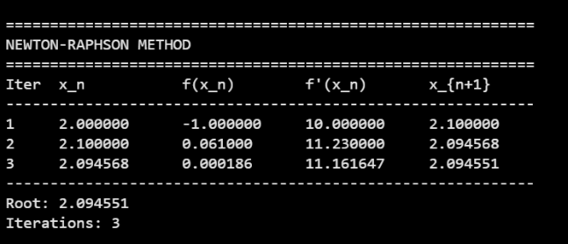
# Example usage
if __name__ == "__main__":
f = lambda x: x**3 - 2*x - 5
df = lambda x: 3*x**2 - 2
newton_raphson(f, df, 2, tol=1e-6)
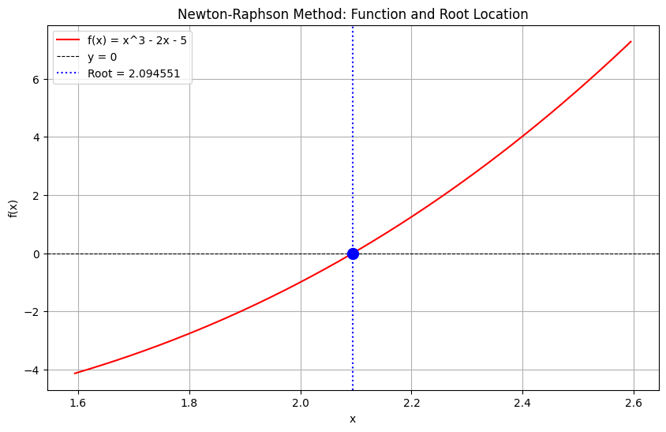
Figure: Visualization of Newton-Raphson method of above function and root location

1.6 Fixed Point Iteration
Principle
Rearrange $f(x)=0$ into the form $x=g(x)$.
- Iteration Formula: $x_{i+1}=g(x_{i})$
- Convergence Criterion: The method converges if $∣g^{'}(x)∣<1$ in the neighborhood of the root.

Algorithm
- Rewrite $f(x)=0$ as $x=g(x)$
- Choose initial guess $x_{0}$
- Compute $x_{1}=g(x_{0})$
- If $∣x_{1}-x_{0}∣<ε$, stop
- Else set $x_{0}=x_{1}$ and repeat
Choosing $g(x)$ Wisely
Different rearrangements give different convergence rates. Choose the one with the smallest $∣g^{'}(x)∣$ near the root.

Problem: Find a root of $x^{3}+x^{2}-1=0$.
Solution:
We can rearrange this in three ways.
- $x=(1-x^{3})^{1/2}$
- $x=\frac{1}{\sqrt{x+1}}$
- $x=(1-x^{2})^{1/3}$
Convergence Check:
At $x≈0.5$:
- $∣g^{'}(0.5)∣≈0.4009<1$
- $∣g^{'}(0.5)∣≈0.4034<1$
- $∣g^{'}(0.5)∣≈0.271<1$ (Smallest, hence fastest convergence).
Using $x_{n+1}=(1-x_{n}^{2})^{1/3}$ with $x_{0}=0.5$:
$$x_{1}=(1-0.25)^{1/3}=(0.75)^{1/3}≈0.9086 \\ x_{2}=(1-0.8255)^{1/3}≈0.5591$$Converging slowly to the actual root near 0.7549.
Python Code:
# Fixed Point Iteration Method
import math

def fixed_point(g, x0, tol=1e-6, max_iter=100):
"""
Find root using Fixed Point Iteration Method

Parameters:
g: iteration function (x = g(x))
x0: initial guess
tol: tolerance
max_iter: maximum iterations
"""
print("\n" + "="*60)
print("FIXED POINT ITERATION")
print("="*60)
print(f"{'Iter':<6}{'x_n':<14}{'x_{n+1}':<14}{'|x_{n+1}-x_n|':<14}")
print("-"*60)

x = x0

for i in range(max_iter):
x_new = g(x)
Output
error = abs(x_new - x)

print(f"{i+1:<6}{x:<14.6f}{x_new:<14.6f}{error:<14.6f}")

if error < tol:
print("-"*60)
print(f"Root: {x_new:.6f}")
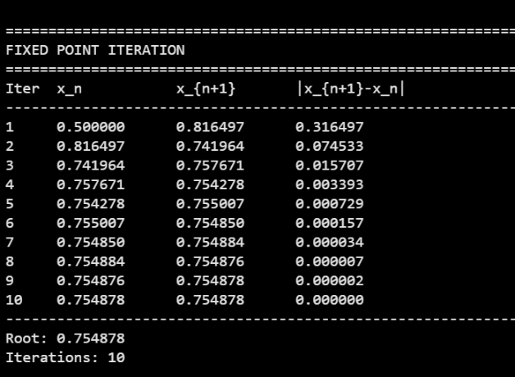
print(f"Iterations: {i+1}")
return x_new

x = x_new

print("Method did not converge")
return None

# Example usage
if __name__ == "__main__":
# For x^3 + x^2 - 1 = 0, rearrange as x = 1/sqrt(x+1)
g = lambda x: 1 / math.sqrt(x + 1)
fixed_point(g, 0.5, tol=1e-6)

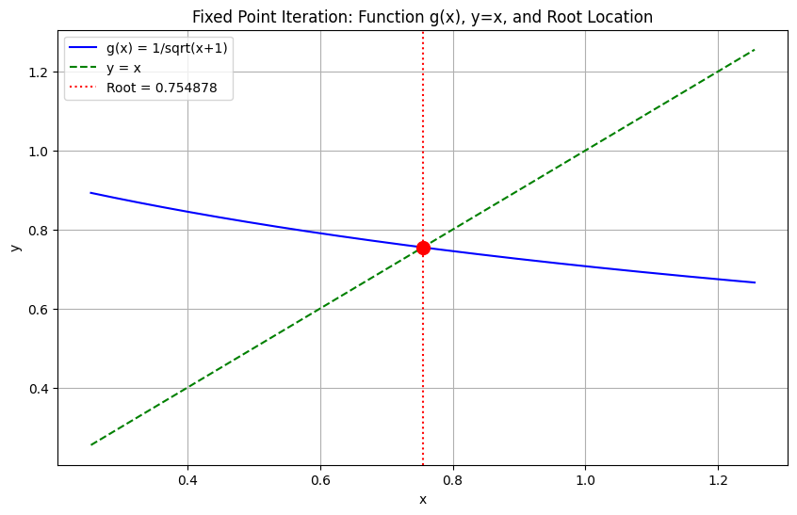
Figure: Visualization of Fixed-Point Iteration method of above function and root location

1.7 Comparison of Methods
Method | Type | Initial Guesses | Speed | Derivative Needed | Guaranteed?
Bisection | Bracketing | 2 | Slow | No | Yes
Regula Falsi | Bracketing | 2 | Medium | No | Yes
Secant | Open | 2 | Fast | No | No
Newton-Raphson | Open | 1 | Very Fast | Yes | No
Fixed Point | Open | 1 | Varies | No | No (depends on $g^{'}(x)$)

When to Use Which Method?
Situation | Recommended Method
Need guaranteed convergence | Bisection or Regula Falsi
Derivative is easily available | Newton-Raphson
Derivative is difficult to compute | Secant or Fixed Point
Need very high precision | Newton-Raphson
Only need rough estimate | Bisection

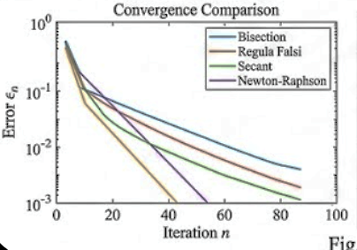
Figure: Method Comparison and Rates of Convergence

1.8 Solution of System of Non-Linear Equations
1.8.1 Direct Approach (Simple Substitution)
Solve one equation for one variable and substitute into the other.
Example:
$$\left\{\begin{aligned}x^{2}+y^{2}=25 \\ x+y=7\end{aligned}\right.$$
From the second: $y=7-x$.
Substitute into first: $x^{2}+(7-x)^{2}=25$
Solve for $x$, then find $y$.
1.8.2 Newton-Raphson Method for Systems
For two equations:
$$\left\{\begin{aligned}f(x,y)=0 \\ g(x,y)=0\end{aligned}\right.$$
The iteration formula:
$$\left[\begin{aligned}x_{n+1} \\ y_{n+1}\end{aligned}\right]=\left[\begin{aligned}x_{n} \\ y_{n}\end{aligned}\right]-J^{-1}\left[\begin{aligned}f(x_{n},y_{n}) \\ g(x_{n},y_{n})\end{aligned}\right]$$
Where $J$ is the Jacobian matrix:
$$J=\left[\begin{matrix}\frac{∂f}{∂x} & \frac{∂f}{∂y} \\ \frac{∂g}{∂x} & \frac{∂g}{∂y}\end{matrix}\right]$$
Algorithm
- Choose initial guesses $\left(x_{0} , y_{0}\right)$
- Compute $f,g$ and Jacobian at $\left(x_{n} , y_{n}\right)$
- Solve the linear system $J⋅Δ=-[f,g]^{T}$
- Update: $x_{n+1}=x_{n}+Δ_{x}$, $y_{n+1}=y_{n}+Δ_{y}$
- Repeat until $∣Δ∣<ε$

Python code:
# Newton-Raphson Method for System of Non-Linear Equations
import math

def newton_system(f, g, dfdx, dfdy, dgdx, dgdy, x0, y0, tol=1e-6, max_iter=100):
"""
Solve system of non-linear equations:
f(x, y) = 0
g(x, y) = 0

Using Newton-Raphson Method

Parameters:
f, g: functions
dfdx, dfdy, dgdx, dgdy: partial derivatives
x0, y0: initial guesses
tol: tolerance
max_iter: maximum iterations
"""
print("\n" + "="*70)
print("NEWTON-RAPHSON METHOD FOR SYSTEM OF EQUATIONS")
print("="*70)
print(f"{'Iter':<6}{'x':<14}{'y':<14}{'f(x,y)':<14}{'g(x,y)':<14}")
print("-"*70)

x, y = x0, y0

for i in range(max_iter):
f_val = f(x, y)
g_val = g(x, y)

# Jacobian matrix
J11 = dfdx(x, y)
J12 = dfdy(x, y)
J21 = dgdx(x, y)
J22 = dgdy(x, y)

# Determinant
det = J11 * J22 - J12 * J21

if abs(det) < 1e-12:
print("Jacobian determinant is zero. Method fails.")
return None

# Solve for increments
dx = (-f_val * J22 + g_val * J12) / det
dy = (-g_val * J11 + f_val * J21) / det

x_new = x + dx
y_new = y + dy

print(f"{i+1:<6}{x:<14.6f}{y:<14.6f}{f_val:<14.6f}{g_val:<14.6f}")

if abs(dx) < tol and abs(dy) < tol:
print("-"*70)
print(f"Root: x = {x_new:.6f}, y = {y_new:.6f}")
print(f"Iterations: {i+1}")
return x_new, y_new

x, y = x_new, y_new

print("Method did not converge")
return None

# Example usage
if __name__ == "__main__":
# System: x^2 + y^2 = 4, x^2 - y^2 = 1
f = lambda x, y: x**2 + y**2 - 4
g = lambda x, y: x**2 - y**2 - 1

dfdx = lambda x, y: 2*x
dfdy = lambda x, y: 2*y
dgdx = lambda x, y: 2*x
dgdy = lambda x, y: -2*y

newton_system(f, g, dfdx, dfdy, dgdx, dgdy, 1.5, 1.0, tol=1e-6)
output:
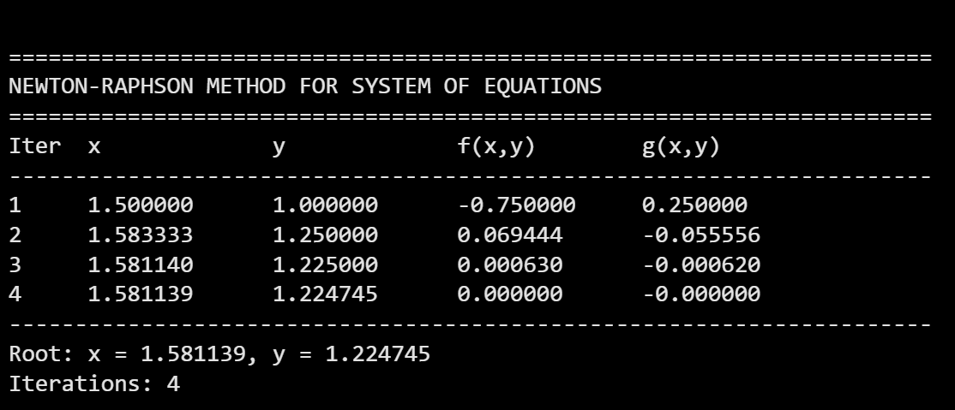
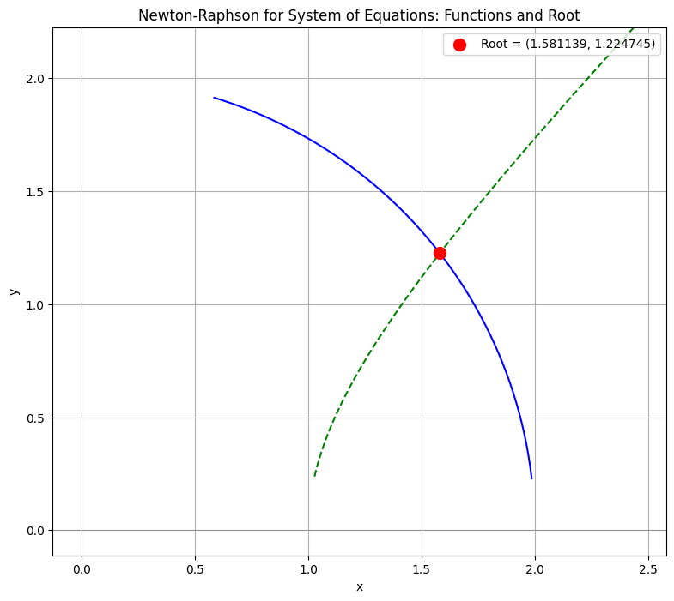

Interpolation And Curve Fitting
Prepared by: Er. Rubi Kumari Mahato

3.1.1 Finite Differences
1. Introduction
In numerical analysis, finite differences approximate derivatives and help construct interpolation polynomials (Newton’s forward/backward formulas). They are computed from equally spaced data.
Given $y=f(x)$ with values $y_{i}=f(x_{i})$ at points $x_{i}=x_{0}+ih$ (equispaced).
2. Notation for Finite Differences
Difference Type | Symbol | Definition
Forward | $$Δ$$ | $$Δy_{i}=y_{i+1}-y_{i}$$
Backward | $$∇$$ | $∇y_{i}=y_{i}-y_{i-1}$
Central | $$δ$$ | $$δy_{i}=y_{i+1/2}-y_{i-1/2}$$
Divided |  | $f[x_{i},x_{i+1}]=\frac{f(x_{i+1})-f(x_{i})}{x_{i+1}-x_{i}}$ (unequal spacing)

3. Forward Difference Table
Definition:
Let $y_{i}=f(x_{i})$ for $i=0,1,2,…$ with constant spacing $h=x_{i+1}-x_{i}$.
First forward difference:
$$Δy_{i}=y_{i+1}-y_{i}$$
Second forward difference:
$$Δ^{2}y_{i}=Δ(Δy_{i})=Δy_{i+1}-Δy_{i}$$
Third forward difference:
$$Δ^{3}y_{i}=Δ(Δ^{2}y_{i})=Δ^{2}y_{i+1}-Δ^{2}y_{i}$$
General $n$-th forward difference:
$$Δ^{n}y_{i}=Δ^{n-1}y_{i+1}-Δ^{n-1}y_{i},n≥1$$
with $Δ^{0}y_{i}=y_{i}$.

$$Δy_{i}=y_{i+1}-y_{i} \\ Δ^{2}y_{i}=Δ(Δy_{i})=Δy_{i+1}-Δy_{i}$$
and so on.
Table structure
(example with 5 points):
$$x$$ | $$y$$ | $$Δ$$ | $$Δ^{2}$$ | $$Δ^{3}$$ | $$Δ^{4}$$
$$x_{0}$$ | $$y_{0}$$
 |  | $$Δy_{0}$$
$$x_{1}$$ | $$y_{1}$$ |  | $$Δ^{2}y_{0}$$
 |  | $$Δy_{1}$$ |  | $$Δ^{3}y_{0}$$
$$x_{2}$$ | $$y_{2}$$ |  | $$Δ^{2}y_{1}$$ |  | $$Δ^{4}y_{0}$$
 |  | $$Δy_{2}$$ |  | $$Δ^{3}y_{1}$$
$$x_{3}$$ | $$y_{3}$$ |  | $$Δ^{2}y_{2}$$
 |  | $$Δy_{3}$$
$$x_{4}$$ | $$y_{4}$$

4. Backward Difference Table
Definition:
$$∇y_{i}=y_{i}-y_{i-1} \\ ∇^{2}y_{i}=∇y_{i}-∇y_{i-1}$$
Table structure:
$$x$$ | $$y$$ | $$∇$$ | $$∇^{2}$$ | $$∇^{3}$$
$$x_{0}$$ | $$y_{0}$$
$$x_{1}$$ | $$y_{1}$$ | $$∇y_{1}$$
$$x_{2}$$ | $$y_{2}$$ | $$∇y_{2}$$ | $$∇^{2}y_{2}$$
$$x_{3}$$ | $$y_{3}$$ | $$∇y_{3}$$ | $$∇^{2}y_{3}$$ | $$∇^{3}y_{3}$$
$$x_{4}$$ | $$y_{4}$$ | $$∇y_{4}$$ | $$∇^{2}y_{4}$$ | $$∇^{3}y_{4}$$

- (Usually diagonal arrangement for interpolation near end of table.)

5. Central Difference Table
Definition: Use half-index notation:
$$δy_{i+1/2}=y_{i+1}-y_{i}$$
But standard central difference (for even orders):
$$δy_{i}=y_{i+1/2}-y_{i-1/2}$$
In practice, table uses integer indices with averaging for odd differences:

$$x$$ | $$y$$ | $δ$ (1st central) | $$δ^{2}$$ | $$δ^{3}$$
$$x_{0}$$ | $$y_{0}$$
 |  | $$δy_{1/2}=y_{1}-y_{0}$$
$$x_{1}$$ | $$y_{1}$$ |  | $$δ^{2}y_{1}=y_{2}-2y_{1}+y_{0}$$
 |  | $$δy_{3/2}=y_{2}-y_{1}$$ |  | $$δ^{3}y_{3/2}$$
$$x_{2}$$ | $$y_{2}$$ |  | $$δ^{2}y_{2}$$
Often mean or shift operator notation used: $δy_{i}=y_{i+1/2}-y_{i-1/2}$ requires half indices.
6. Divided Difference Table (for unequally spaced data)
Definition:
$$f[x_{i}]=f(x_{i}) \\ f[x_{i},x_{i+1}]=\frac{f[x_{i+1}]-f[x_{i}]}{x_{i+1}-x_{i}} \\ f[x_{i},x_{i+1},x_{i+2}]=\frac{f[x_{i+1},x_{i+2}]-f[x_{i},x_{i+1}]}{x_{i+2}-x_{i}}$$
Table:
$$x$$ | $$f[ ]$$ | $$f[ , ]$$ | $$f[ , , ]$$
$$x_{0}$$ | $$f_{0}$$
 |  | $$f[x_{0},x_{1}]$$
$$x_{1}$$ | $$f_{1}$$ |  | $$f[x_{0},x_{1},x_{2}]$$
 |  | $$f[x_{1},x_{2}]$$
$$x_{2}$$ | $$f_{2}$$ |  | $$f[x_{1},x_{2},x_{3}]$$
 |  | $$f[x_{2},x_{3}]$$
$$x_{3}$$ | $$f_{3}$$

Important Properties of Finite Differences
- Operator relation (for step $h$):
  - Forward: $Δ=E-I$
  - Backward: $∇=I-E^{-1}$
  - Central: $δ=E^{1/2}-E^{-1/2}$
where $Ef(x)=f(x+h)$, $I$ identity.
- Relation between forward and backward differences:
$$∇y_{i}=Δy_{i-1},∇^{2}y_{i}=Δ^{2}y_{i-2}$$
- Relation with derivatives (for $y$ polynomial degree $n$):
  - $Δ^{n}y_{i}=h^{n} y^{\left(n\right)}(ξ)$ for some $ξ$.
  - If $y$ is polynomial degree $n$, $Δ^{n+1}y_{i}=0$.
- Symmetry: Central differences are symmetric; forward/backward are one-sided.
- Linear operator: All differences are linear:
$$Δ(αy_{i}+βz_{i})=αΔy_{i}+βΔz_{i}$$
- Difference of constant: $Δc=0$, $∇c=0$.
- Shift property:
$$Δ^{n}y_{i}=\sum_{k=0}^{n}{(-1})^{n-k}\left({n \atop k}\right)y_{i+k} \\ ∇^{n}y_{i}=\sum_{k=0}^{n}{(-1})^{k}\left({n \atop k}\right)y_{i-k}$$
- Summation (antidifference):
$$\sum_{i=0}^{n-1}{Δ}y_{i}=y_{n}-y_{0}$$
analogous to integration.
- Divided differences are symmetric:
$$f[x_{0},x_{1},…,x_{n}]\text{ is independent of order of arguments}.$$
- Divided difference & derivative:
If $f$ is $n$ times differentiable,
$$f[x_{0},x_{1},…,x_{n}]=\frac{f^{\left(n\right)}(ξ)}{n!}\text{for some }ξ$$
If $f$ is polynomial degree $n$, divided difference of order $n$ is constant.
- Error in interpolation: Remainder terms expressed in terms of finite/divided differences.

3.1.2 Interpolation with Equidistant Points
Suppose we are given the following values of $y=f(x)$ for a set of values $x_{0},x_{1},x_{2},…,x_{n}$:

$$x$$ | $$x_{0}$$ | $$x_{1}$$ | $$x_{2}$$ | $$…$$ | $$x_{n}$$
$$y$$ | $$y_{0}$$ | $$y_{1}$$ | $$y_{2}$$ | $$…$$ | $$y_{n}$$

Definition: The process of finding the value of $y$ corresponding to any value of $x=x_{0}$ between $x_{0}$ and $x_{n}$ is called interpolation.
Extrapolation: Finding values outside the given range.

① Newton's Forward Interpolation Formula
This formula is used when the function is tabulated at equal intervals:
$$x_{2}-x_{1}=x_{3}-x_{2}=⋯=x_{n}-x_{n-1}=h$$
Forward Differences:
- First forward difference: $Δf_{i}=f_{i+1}-f_{i}$
- Second forward difference: $Δ^{2}f_{i}=Δf_{i+1}-Δf_{i}=f_{i+2}-2f_{i+1}+f_{i}$
Formula:
Let $P=\frac{x-x_{0}}{h}$. Then:
$$y_{P}=y_{0}+PΔy_{0}+\frac{P(P-1)}{2!}Δ^{2}y_{0}+\frac{P(P-1)(P-2)}{3!}Δ^{3}y_{0}+⋯+\frac{P(P-1)⋯(P-n+1)}{n!}Δ^{n}y_{0}$$

Example 1: Estimate $f(0.16)$

$$x$$ | 0.1 | 0.2 | 0.3 | 0.4
$$f(x)$$ | 1.005 | 1.020 | 1.045 | 1.081

Solution:
Step 1: Identify values
- $x_{0}=0.1$, $h=0.1$
- $y_{0}=1.005$, $y_{1}=1.020$, $y_{2}=1.045$, $y_{3}=1.081$
Step 2: Calculate forward differences

$$x$$ | $$y$$ | $$Δy$$ | $$Δ^{2}y$$ | $$Δ^{3}y$$
0.1 | 1.005
0.2 | 1.020 | 0.015
0.3 | 1.045 | 0.025 | 0.010
0.4 | 1.081 | 0.036 | 0.011 | 0.001
So:
- $Δy_{0}=0.015$
- $Δ^{2}y_{0}=0.010$
- $Δ^{3}y_{0}=0.001$
Step 3: Compute $P$
$$P=\frac{x-x_{0}}{h}=\frac{0.16-0.1}{0.1}=0.6$$
Step 4: Apply Newton's forward formula
$$y_{P}=y_{0}+PΔy_{0}+\frac{P(P-1)}{2!}Δ^{2}y_{0}+\frac{P(P-1)(P-2)}{3!}Δ^{3}y_{0} \\ y_{P}=1.005+0.6(0.015)+\frac{0.6×(-0.4)}{2}(0.010)+\frac{0.6×(-0.4)×(-1.4)}{6}(0.001) \\ y_{P}=1.005+0.009+\frac{-0.24}{2}(0.010)+\frac{0.336}{6}(0.001) \\ y_{P}=1.014+(-0.12)(0.010)+(0.056)(0.001) \\ y_{P}=1.014-0.0012+0.000056 \\ y_{P}=1.012856$$
Answer: $\boxed{f(0.16)≈1.0129}$

Example 2: Estimate $y(2)$ and $y(3.5)$
$$x$$ | 3 | 4 | 5 | 6 | 7 | 8 | 9
$$y$$ | 4.8 | 8.4 | 14.5 | 23.6 | 36.2 | 52.8 | 73.9

Difference Table:
$$x$$ | $$y$$ | $$Δy$$ | $$Δ^{2}y$$ | $$Δ^{3}y$$ | $$Δ^{4}y$$ | $$Δ^{5}y$$
3 | 4.8 | 3.6
4 | 8.4 | 6.1 | 2.5
5 | 14.5 | 9.1 | 3.0 | 0.5
6 | 23.6 | 12.6 | 3.5 | 0.5 | 0
7 | 36.2 | 16.6 | 4.0 | 0.5 | 0 | 0
8 | 52.8 | 21.1 | 4.5 | 0.5 | 0 | 0
9 | 73.9

For $x=2$ (near beginning, use forward formula):
Take $x_{0}=3$, $y_{0}=4.8$, $h=1$
$$P=\frac{2-3}{1}=-1 \\ y_{P}=4.8+(-1)(3.6)+\frac{\left(-1)(-2\right)}{2}(2.5)+\frac{\left(-1)(-2)(-3\right)}{6}(0.5)+… \\ y_{P}=4.8-3.6+2.5-0.5=3.2$$
For $x=3.5$:
$$P=\frac{3.5-3}{1}=0.5 \\ y_{P}=4.8+0.5(3.6)+\frac{0.5(-0.5)}{2}(2.5)+\frac{0.5(-0.5)(-1.5)}{6}(0.5) \\ y_{P}=4.8+1.8-0.3125+0.03125=6.31875$$

② Newton's Backward Interpolation Formula
Used for interpolation near the end of the table.
Formula:
Let $P=\frac{x-x_{n}}{h}$. Then:
$$y_{P}=y_{n}+P∇y_{n}+\frac{P(P+1)}{2!}∇^{2}y_{n}+…$$

③ Central Difference Formulas
Newton's forward and backward formulas are not suitable near the middle of the table. Central difference formulas are used instead.
Stirling's Formula
For $P$ lying between $-\frac{1}{4}$ and $\frac{1}{4}$ (i.e., $-0.25$ to $0.25$):
$$y_{P}=y_{0}+P\left(\frac{Δy_{0}+Δy_{-1}}{2}\right)+\frac{P^{2}}{2!}Δ^{2}y_{-1}+\frac{P(P^{2}-1)}{3!}\left(\frac{Δ^{3}y_{-1}+Δ^{3}y_{-2}}{2}\right)+\frac{P^{2}(P^{2}-1)}{4!}Δ^{4}y_{-2}+…$$
Where $P=x-x_{m}$ (distance from central point).

Example: Find $f(3.2)$
$$x$$ | 1 | 2 | 3 | 4 | 5 | 6
$$y$$ | 0 | 0.602 | 1.4313 | 2.4082 | 3.4948 | —
Solution:
Step 1: Construct difference table centered at $x=3$
Let $x_{0}=3$, $y_{0}=1.4313$, $h=1$
$$x$$ | $$y$$ | $$Δy$$ | $$Δ^{2}y$$ | $$Δ^{3}y$$ | $$Δ^{4}y$$
1 | 0
2 | 0.602 | 0.602
3 | 1.4313 | 0.8293 | 0.2273
4 | 2.4082 | 0.9769 | 0.1476 | -0.0797
5 | 3.4948 | 1.0866 | 0.1097 | -0.0379 | 0.0418

So:
- $Δy_{-1}=0.8293$ (from $x=2$ to $x=3$)
- $Δy_{0}=0.9769$ (from $x=3$ to $x=4$)
- $Δ^{2}y_{-1}=0.1476$
- $Δ^{3}y_{-2}=-0.0797$? Wait, let me re-index carefully.
Better to use standard Stirling notation with $x_{0}$ as center:
At $x_{0}=3$:
- $y_{0}=1.4313$
- $Δy_{-1}=y_{0}-y_{-1}=1.4313-0.602=0.8293$
- $Δy_{0}=y_{1}-y_{0}=2.4082-1.4313=0.9769$
- $Δ^{2}y_{-1}=Δy_{0}-Δy_{-1}=0.9769-0.8293=0.1476$
- $Δ^{3}y_{-2}=?$ at $x_{1}$? Let's use table directly.
From table:
$$Δy_{-2}=0.602,Δy_{-1}=0.8293,Δy_{0}=0.9769,Δy_{1}=1.0866 \\ Δ^{2}y_{-2}=0.2273,Δ^{2}y_{-1}=0.1476,Δ^{2}y_{0}=0.1097 \\ Δ^{3}y_{-2}=-0.0797,Δ^{3}y_{-1}=-0.0379 \\ Δ^{4}y_{-2}=0.0418$$
Step 2: Compute $P$
$$P=x-x_{0}=3.2-3=0.2$$
Step 3: Apply Stirling's formula
$$y_{P}=y_{0}+P\left(\frac{Δy_{0}+Δy_{-1}}{2}\right)+\frac{P^{2}}{2!}Δ^{2}y_{-1}+\frac{P(P^{2}-1)}{3!}\left(\frac{Δ^{3}y_{-1}+Δ^{3}y_{-2}}{2}\right)+\frac{P^{2}(P^{2}-1)}{4!}Δ^{4}y_{-2}$$
Substitute:
$$y_{P}=1.4313+0.2\left(\frac{0.9769+0.8293}{2}\right)+\frac{{\left(0.2\right)}^{2}}{2}(0.1476)+\frac{0.2(0.04-1)}{6}\left(\frac{-0.0379+(-0.0797)}{2}\right)+\frac{\left(0.04)(0.04-1\right)}{24}(0.0418) \\ y_{P}=1.4313+0.2\left(\frac{1.8062}{2}\right)+\frac{0.04}{2}(0.1476)+\frac{0.2(-0.96)}{6}\left(\frac{-0.1176}{2}\right)+\frac{0.04×(-0.96)}{24}(0.0418) \\ y_{P}=1.4313+0.2(0.9031)+0.02(0.1476)+\frac{-0.192}{6}(-0.0588)+\frac{-0.0384}{24}(0.0418) \\ y_{P}=1.4313+0.18062+0.002952+(-0.032)(-0.0588)+(-0.0016)(0.0418) \\ y_{P}=1.614872+0.0018816-0.00006688 \\ y_{P}=1.61668672$$
Answer:
$\boxed{f(3.2)≈1.6166}$

Bessel's Formula
For $P$ lying between $\frac{1}{4}$ and $\frac{3}{4}$ (0.25 to 0.75):
$$y_{P}=y_{0}+PΔy_{0}+\frac{P(P-1)}{2!}\left(\frac{Δ^{2}y_{1}+Δ^{2}y_{0}}{2}\right)+\frac{P(P-1)(P-0.5)}{3!}Δ^{3}y_{1}+…$$
3.1.3. Interpolation with Unequal Intervals
Lagrange's Interpolation Formula
If $y=f(x)$ takes values $y_{0},y_{1},…,y_{n}$ at $x=x_{0},x_{1},…,x_{n}$ (not necessarily equally spaced), then:
$$f(x)=\sum_{i=0}^{n}{y_{i}}⋅\frac{\left(x-x_{0})(x-x_{1})⋯(x-x_{i-1})(x-x_{i+1})⋯(x-x_{n}\right)}{\left(x_{i}-x_{0})(x_{i}-x_{1})⋯(x_{i}-x_{i-1})(x_{i}-x_{i+1})⋯(x_{i}-x_{n}\right)}$$
Or more compactly:
$$P_{n}(x)=\sum_{i=0}^{n}{y_{i}}⋅L_{i}(x)$$
Disadvantage: If a new interpolation value is inserted, all coefficients must be recalculated.
Newton's Divided Difference Formula
Advantage: Less computational operations. If a new point is added, existing coefficients do not need to be recalculated.
In general, the interpolating polynomial is given by:
f(x) = a₀ + a₁(x - x₀) + a₂(x - x₀)(x - x₁) + ... + aₙ(x - x₀)(x - x₁)...(x - xₙ₋₁)
Where:
a₀ = f(x₀) = F[x₀]
a₁ = (f₁ - f₀) / (x₁ - x₀) = F[x₁, x₀]
a₂ = (F[x₂, x₁] - F[x₁, x₀]) / (x₂ - x₀) = F[x₂, x₁, x₀]
aₙ = (F[xₙ, ..., x₁] - F[xₙ₋₁, ..., x₀]) / (xₙ - x₀)

The divided differences are defined as:
- $f[x_{i}]=y_{i}$
- $f[x_{i},x_{i+1}]=\frac{f[x_{i+1}]-f[x_{i}]}{x_{i+1}-x_{i}}$
- $f[x_{i},x_{i+1},x_{i+2}]=\frac{f[x_{i+1},x_{i+2}]-f[x_{i},x_{i+1}]}{x_{i+2}-x_{i}}$
Then:
$$f(x)=f[x_{0}]+(x-x_{0})f[x_{0},x_{1}]+(x-x_{0})(x-x_{1})f[x_{0},x_{1},x_{2}]+…$$

Solved Example:
Q. Given the following set of data points, obtain the table of divided differences. Use the table to estimate the value of P(1.5).
x_i | 1 | 2 | 3 | 4 | 5
f(x_i) | 0 | 7 | 26 | 63 | 124

Divided Difference Table:
x_i | f(x_i) | 1st Diff | 2nd Diff | 3rd Diff
1 | 0 | 7 | 6 | 1
2 | 7 | 19 | 9 | 1
3 | 26 | 37 | 12 | -
4 | 63 | 61 | - | -
5 | 124 | - | - | -

Value of Polynomial at x = 1.5 is computed as follows:
P(1.5) = a₀ + a₁(x - x₀) + a₂(x - x₀)(x - x₁) + a₃(x - x₀)(x - x₁)(x - x₂) + a₄(x - x₀)(x - x₁)(x - x₂)(x - x₃)
Where a₀ = 0, a₁ = 7, a₂ = 6, a₃ = 1, a₄ = 0
P(1.5) = 0 + 7(1.5 - 1) + 6(1.5 - 1)(1.5 - 2) + 1(1.5 - 1)(1.5 - 2)(1.5 - 3) + 0
P(1.5) = 0 + 3.5 + 6(0.5)(-0.5) + 1(0.5)(-0.5)(-1.5)
P(1.5) = 3.5 - 1.5 + 0.375 = 2.375

3.2 Cubic Spline Curve Fitting
We have explored about the different methods of Interpolation. It seems that standard interpolation techniques are not practicable for a large number of data points. Thus, curve fitting techniques have been fitted to the given sets of tabulated data, where a single curve gives a rough approximation of the data.
This method gives a quadratic curve (or simply a cubic curve) only. To minimize this error, the cubic spline is developed where a unique curve between every two consecutive points ensures a smooth, continuous curve.

Conditions for Cubic Spline:
1. f(x) is a linear polynomial outside the interval (x₀, xₙ).
2. f(x) is a cubic polynomial in each of the subintervals.
3. f'(x) and f''(x) are continuous at each point.
4. Since f(x) is cubic in each of the subintervals, f''(x) shall be linear.

Formulas:
For non-equispaced intervals:
$$f_{i,i+1}(x)=\frac{K_{i}}{6}\left[\frac{{\left(x_{i+1}-x\right)}^{3}}{x_{i+1}-x_{i}}-(x_{i+1}-x)(x_{i+1}-x_{i})\right]+\frac{K_{i+1}}{6}\left[\frac{{\left(x-x_{i}\right)}^{3}}{x_{i+1}-x_{i}}-(x-x_{i})(x_{i+1}-x_{i})\right]+\frac{y_{i}(x_{i+1}-x)+y_{i+1}(x-x_{i})}{x_{i+1}-x_{i}}$$
Where $K$ represents $f^{''}(x)$.

Continuity equation for non-equispaced:
$$K_{i-1}(x_{i}-x_{i-1})+2K_{i}(x_{i+1}-x_{i-1})+K_{i+1}(x_{i+1}-x_{i})=6\left[\frac{y_{i+1}-y_{i}}{x_{i+1}-x_{i}} − \frac{y_{i}-y_{i-1}}{x_{i}-x_{i-1}}\right]$$

If the interval is equispaced ($h$):
$$K_{i-1}+4K_{i}+K_{i+1}=\frac{6}{h^{2}}(y_{i-1}-2y_{i}+y_{i+1})$$
Where $i=1,2,…,n-1$.

Boundary conditions (natural spline):
$$K_{0}=0,K_{n}=0$$

💡 Key Insight
The boundary conditions K₀ = 0 and Kₙ = 0 mean the curve is linear (straight) beyond the
outermost data points — a "natural" spline. This gives a unique, well-defined solution.

Solved Example:
Q. Find the cubic splines and evaluate y(1.5) and y'(3) from the following values of x and y:
X | 1 | 2 | 3 | 4
Y | 1 | 2 | 5 | 11

Solution:
Since the points are equispaced with h = 1, we use the equispaced formula:
K_i-1 + 4K_i + K_i+1 = (6/1²) (y_i-1 - 2y_i + y_i+1)
For i = 1:
K₀ + 4K₁ + K₂ = 6(y₀ - 2y₁ + y₂)
0 + 4K₁ + K₂ = 6(1 - 2(2) + 5)
4K₁ + K₂ = 12 ... (1)
For i = 2:
K₁ + 4K₂ + K₃ = 6(y₁ - 2y₂ + y₃)
K₁ + 4K₂ + 0 = 6(2 - 2(5) + 11)
K₁ + 4K₂ = 18 ... (2)
Solving (1) and (2), we get:
K₁ = 2, K₂ = 4
For 1 ≤ x ≤ 2:
f_1,2(x) = (0/6)[...] + (2/6)[(x-1)³/1 - (x-1)(1)] + [1(2-x) + 2(x-1)]/1
f_1,2(x) = 1/3 (x³ - 3x² + 5x)
f_1,2(1.5) = 1/3 ((1.5)³ - 3(1.5)² + 5(1.5)) = 1.375
Alternatively:
As we know from given question,
Spacing $h=2$
Natural spline: $M_{0}=0, M_{4}=0$
Unknowns: $M_{1},M_{2},M_{3}$ (second derivatives at $x=4,6,8$)
Step 1: Matrix system (from standard cubic spline formula)
For $n=5$ points:
$$\frac{6}{h^{2}}=\frac{6}{4}=1.5 \\ \left[\begin{matrix}4 & 1 & 0 \\ 1 & 4 & 1 \\ 0 & 1 & 4\end{matrix}\right]\left[\begin{aligned}M_{1} \\ M_{2} \\ M_{3}\end{aligned}\right]=1.5×\left[\begin{aligned}y_{0}-2y_{1}+y_{2} \\ y_{1}-2y_{2}+y_{3} \\ y_{2}-2y_{3}+y_{4}\end{aligned}\right]$$
Step 2: Compute RHS
$$y_{0}-2y_{1}+y_{2}=7-2(6)+9=4 \\ y_{1}-2y_{2}+y_{3}=6-2(9)+11=-1 \\ y_{2}-2y_{3}+y_{4}=9-2(11)+8=-5$$
Multiply by 1.5:
$$\text{RHS}=\left[\begin{aligned}6 \\ -1.5 \\ -7.5\end{aligned}\right]$$
Step 3: Matrix equation
$$\left[\begin{matrix}4 & 1 & 0 \\ 1 & 4 & 1 \\ 0 & 1 & 4\end{matrix}\right]\left[\begin{aligned}M_{1} \\ M_{2} \\ M_{3}\end{aligned}\right]=\left[\begin{aligned}6 \\ -1.5 \\ -7.5\end{aligned}\right]$$
Step 4: Solve
From row 1: $4M_{1}+M_{2}=6⇒M_{2}=6-4M_{1}$
From row 3: $M_{2}+4M_{3}=-7.5$
Substitute $M_{2}$: $6-4M_{1}+4M_{3}=-7.5$
$$-4M_{1}+4M_{3}=-13.5$$Divide 4: $-M_{1}+M_{3}=-3.375⇒M_{3}=M_{1}-3.375$
From row 2: $M_{1}+4M_{2}+M_{3}=-1.5$
Substitute $M_{2},M_{3}$:
$$M_{1}+4(6-4M_{1})+(M_{1}-3.375)=-1.5 \\ M_{1}+24-16M_{1}+M_{1}-3.375=-1.5 \\ -14M_{1}+20.625=-1.5 \\ -14M_{1}=-22.125 \\ M_{1}=1.580357$$
Then:
$$M_{2}=6-4(1.580357)=-0.321428 \\ M_{3}=1.580357-3.375=-1.794643$$
So:
$$M_{1}=1.5804,M_{2}=-0.3214,M_{3}=-1.7946$$
Step 5: Find $Y(5)$
$x=5$ is in interval $\left[4 , 6\right]$ → between $x_{1}=4,x_{2}=6$
Here:
$$h=2, M_{1}=1.5804, M_{2}=-0.3214, y_{1}=6, y_{2}=9$$
Cubic spline formula for $\left[x_{1} , x_{2}\right]$:
$$S(x)=\frac{M_{1}}{6h}(x_{2}-x)^{3}+\frac{M_{2}}{6h}(x-x_{1})^{3}+\left(\frac{y_{2}}{h} − \frac{M_{2}h}{6}\right)(x-x_{1})+\left(\frac{y_{1}}{h} − \frac{M_{1}h}{6}\right)(x_{2}-x)$$
For $x=5$: $x-x_{1}=1, x_{2}-x=1$
$$6h=12, h/6=2/6=1/3$$
$$S(5)=\frac{1.5804}{12}(1)^{3}+\frac{-0.3214}{12}(1)^{3}+\left(\frac{9}{2} − \frac{(-0.3214)×2}{6}\right)(1)+\left(\frac{6}{2} − \frac{1.5804×2}{6}\right)(1) \\ =0.1317-0.02678+\left(4.5 + 0.10713\right)+\left(3 − 0.5268\right) \\ =0.10492+4.60713+2.4732 \\ =7.18525$$
Final Answer
$$\boxed{Y(5)=7.185}$$

3. 3 Least Square Curve Fitting
The process of establishing a relationship between variables and expressing it in a Mathematical equation is known as regression analysis or curve fitting. The relation may be linear or non-linear.

3.3.1 Fitting Linear Equation
This is the simplest approach of regression analysis where we fit the equation of a straight line to the variables:
y = a + bx
Normal Equations:
$$∑yi​=na+b∑xi​$$
$$∑x_{i}y_{i}=a∑x_{i}+b∑x_{i}^{2} \\ b=\frac{n∑x_{i}y_{i}-∑x_{i}∑y_{i}}{n∑x_{i}^{2}-(∑x_{i})^{2}} \\ a=\frac{∑y_{i}}{n}-b\left(\frac{∑x_{i}}{n}\right)$$

Q. Find a straight line to fit the following set of data:
x | 1 | 2 | 3 | 4 | 5
y | 3 | 4 | 5 | 6 | 8

Step 1: Calculate sums
$$∑x=1+2+3+4+5=15 \\ ∑y=3+4+5+6+8=26 \\ ∑x^{2}=1^{2}+2^{2}+3^{2}+4^{2}+5^{2}=1+4+9+16+25=55 \\ ∑xy=(1)(3)+(2)(4)+(3)(5)+(4)(6)+(5)(8)=3+8+15+24+40=90$$
Step 2: Normal equations
$$∑y=na+b∑x \\ ∑xy=a∑x+b∑x^{2}$$
Substitute values:
$$26=5a+15b(1) \\ 90=15a+55b(2)$$
Step 3: Solve for $a$ and $b$
From (1): $5a=26-15b$ → $a=\frac{26-15b}{5}$
Substitute into (2):
$$90=15\left(\frac{26-15b}{5}\right)+55b \\ 90=3(26-15b)+55b \\ 90=78-45b+55b \\ 90=78+10b \\ 10b=12 \\ b=1.2$$
Then:
$$a=\frac{26-15(1.2)}{5}=\frac{26-18}{5}=\frac{8}{5}=1.6$$
Step 4: Final equation
$$\boxed{y=1.6+1.2x}$$

3.3.2 Fitting Transactional Equation (Power Method)
The non-linear equation between variables can be a power function expressed as:
$$y = ax^{b}$$
Taking Natural log (ln) on both sides:
$$ln(y) = ln(a) + b ln(x)$$
Let Y = ln(y), A = ln(a), B = b, X = ln(x). This is now in linear form:
$$Y = A + BX \\ Where a = exp(A)$$

Q. Fit the following data using the power method:

X | 1 | 2 | 3 | 4 | 5
Y | 0.5 | 2 | 4.5 | 8 | 12.5

Step 1: Transform for power law $y=ax^{b}$
Take logs:
$$Y^{'}=ln⁡y,{ X}^{'}=ln⁡x$$
Then equation becomes:
$$Y^{'}=ln⁡a+bX^{'}$$
Step 2: Calculate summations
Given:
$$∑X^{'}=4.7874,∑Y^{'}=6.1092 \\ ∑(X^{'})^{2}=6.1993,∑(X^{'}Y^{'})=9.0804$$
$$n=5$$
Step 3: Find $b$ (slope)
$$b=\frac{n∑(X^{'}Y^{'})-∑X^{'}∑Y^{'}}{n∑(X^{'})^{2}-(∑X^{'})^{2}} \\ b=\frac{5×9.0804-4.7874×6.1092}{5×6.1993-(4.7874)^{2}} \\ b=1.9998≈2$$
Step 4: Find $\ln{a}$
$$ln⁡a=\frac{∑Y^{'}}{n}-b⋅\frac{∑X^{'}}{n} \\ ln⁡a=\frac{6.1092}{5}-1.9998×\frac{4.7874}{5} \\ ln⁡a=-0.6929$$

Step 5: Find $a$
$$a=e^{\ln{a}}=e^{-0.6929}=0.5001≈0.5$$

Step 6: Power function equation
$$\boxed{y=0.5x^{2}}$$

3.2.3 Fitting Exponential Equation
The curve is given by:
y = ae^{bx}
Taking natural log (ln) on both sides:
ln(y) = ln(a) + bx ln(e) => ln(y) = ln(a) + bx
Which is of the form Y = A + Bx, where Y = ln(y), A = ln(a), B = b.
Q. Obtain a relation of the form y = ae^{bx} for the following data:
X | 0.5 | 1.0 | 1.5 | 2.0 | 2.5
Y | 0.1 | 0.45 | 2.15 | 9.15 | 40.35

Let $Y^{'}=ln⁡y$, $A=ln⁡a$, $B=λ$, so the linear equation is $Y^{'}=A+Bx$.
$$x$$ | $$y$$ | $$Y^{'}=ln⁡y$$ | $$x^{2}$$ | $$x⋅Y^{'}$$
0.5 | 0.10 | -2.302585 | 0.25 | -1.1512925
1.0 | 0.45 | -0.798508 | 1.00 | -0.798508
1.5 | 2.15 | 0.765468 | 2.25 | 1.148202
2.0 | 9.15 | 2.213762 | 4.00 | 4.427524
2.5 | 40.35 | 3.698060 | 6.25 | 9.245150
Sum |  | 3.576197 | 13.75 | 12.8710755
$n=5$, $∑x=7.5$
Using the transformed linear regression, we get:
B = 2.9962
A = -2.28314 => a = exp(-2.28314) = 0.1
Hence the regression curve is: y = 0.1e^{^{2.9962x}}

* Fitting Non-Linear Form T = be^{t/4} + a
Q. Temperature (T) of a metal strip was measured at various time intervals (t). Find T at t = 6.
T | 1 | 2 | 3 | 4
T | 70 | 83 | 100 | 124

Let X = e^{t/4} . The equation becomes T = bX + a.
$$t$$ | $T$ (given) | $$X=e^{t/4}$$ | $$X^{2}$$ | $$T⋅X$$
1 | 70 | $$2840$$ | 1.6487 | 89.88
2 | 83 | $$1.6487$$ | 2.7183 | 136.84
3 | 100 | $$2.1170$$ | 4.4817 | 211.70
4 | 124 | $$2.7183$$ | 7.3891 | 337.07
Sum | 377 | 7.7680 | 16.2378 | 775.49

We have,
Normal equations for $T=a+bX$
$$∑T=na+b∑X \\ ∑XT=a∑X+b∑X^{2}$$
Substitute:
$$377=4a+7.768028b………(1) \\ 775.49256=7.768028a+16.23775b………(2)$$
On Solving
From (1): $4a=377-7.768028b$ → $a=\frac{377-7.768028b}{4}$
Sub into (2):
$$775.49256=7.768028×\frac{377-7.768028b}{4}+16.23775b$$
Multiply through by 4:
$$3101.97024=7.768028(377-7.768028b)+64.951b \\ 3101.97024=2927.3466-60.341b+64.951b \\ 3101.97024=2927.3466+4.61b \\ 174.62364=4.61b \\ b≈37.88$$
Then:
$$a=\frac{377-7.768028×37.88}{4} \\ =\frac{377-294.2}{4}=\frac{82.8}{4}=20.7$$
Fit equation
$$T=37.6225e^{t/4}+21.1881$$
Find $T$ at $t=6$
$$e^{6/4}=e^{1.5}≈4.481689$$
$$T(6)=37.6225×4.481689+21.1881 \\ =168.60+21.1881=189.7881≈189.79$$
$$\boxed{T≈{189.79}^{∘}C}$$

3.2.3 Fitting the 2nd Order Polynomial
The 2nd order polynomial is given as:
y = a + bx + cx²
Normal equations:
$$∑y = na + b∑x + c∑x² \\ ∑xy = a∑x + b∑x² + c∑x³ \\ ∑x²y = a∑x² + b∑x³ + c∑x⁴$$
Q. Fit the 2nd order polynomial with data:
X | 1 | 2 | 3 | 4
Y | 6 | 11 | 18 | 27

Solution:
Consider the following tabulation:
$$x$$ | $$y$$ | $$x^{2}$$ | $$x^{3}$$ | $$x^{4}$$ | $$xy$$ | $$x^{2}y$$
1 | 6 | 1 | 1 | 1 | 6 | 6
2 | 11 | 4 | 8 | 16 | 22 | 44
3 | 18 | 9 | 27 | 81 | 54 | 162
4 | 27 | 16 | 64 | 256 | 108 | 432

Calculation Summations:
∑x = 10,
∑y = 62,
∑x² = 30,
∑x³ = 100,
∑x⁴ = 354,
∑xy = 190,
∑x²y = 644
Normal equations
For $y=a+bx+cx^{2}$:
$$∑y=na+b∑x+c∑x^{2} \\ ∑xy=a∑x+b∑x^{2}+c∑x^{3} \\ ∑x^{2}y=a∑x^{2}+b∑x^{3}+c∑x^{4}$$
Substitute values:
$$62=4a+10b+30c(1) \\ 190=10a+30b+100c(2) \\ 644=30a+100b+354c(3)$$

Solve
From (1): Divide by 2 → $31=2a+5b+15c$ … keep as is.
Better: Solve systematically.
From (1): $4a=62-10b-30c$ → $a=\frac{62-10b-30c}{4}$ … (1′)
Sub into (2):
$$190=10\left(\frac{62-10b-30c}{4}\right)+30b+100c$$
Multiply by 4:
$$760=10(62-10b-30c)+120b+400c \\ 760=620-100b-300c+120b+400c \\ 760=620+20b+100c \\ 140=20b+100c$$
Divide 20: $7=b+5c$ … (4)
Sub into (3):
$$644=30\left(\frac{62-10b-30c}{4}\right)+100b+354c$$
Multiply by 4:
$$2576=30(62-10b-30c)+400b+1416c \\ 2576=1860-300b-900c+400b+1416c \\ 2576=1860+100b+516c \\ 716=100b+516c$$
Divide 4: $179=25b+129c$ … (5)
From (4): $b=7-5c$
Sub into (5):
$$179=25(7-5c)+129c \\ 179=175-125c+129c \\ 179=175+4c \\ 4c=4⇒c=1$$
Then $b=7-5(1)=2$
From (1′): $a=\frac{62-10(2)-30(1)}{4}=\frac{62-20-30}{4}=\frac{12}{4}=3$

Final polynomial
$$\boxed{y=3+2x+x^{2}}$$

Solution of Ordinary Differential Equations
Prepared by: Er. Rubi Kumari Mahato

Introduction
The solution of an ordinary differential equation means finding an explicit expression for $y$ in terms of a finite number of elementary functions of $x$. Such a solution of a differential equation is known as the Closed or Finite form of Solution.

5.1 Initial Value Problems
Taylor's Series Method
Given $\frac{dy}{dx}=f(x,y)$, $y(x_{0})=y_{0}$, the Taylor series expansion is:
$$y(x_{0}+h)=y_{0}+hy_{0}^{'}+\frac{h^{2}}{2!}y_{0}^{''}+\frac{h^{3}}{3!}y_{0}^{'''}+…$$
where $y_{0}^{'}=f(x_{0},y_{0})$, and higher derivatives are obtained by differentiating $f(x,y)$ with respect to $x$.

Euler's Method (1st Order RK-Method)
Simplest method but it has limited application because of its low accuracy. Consider the equation
$$\frac{dy}{dx}=f(x,y)$$
given that $y(x_{0})=y_{0}$. Its curve of solution through $P(x_{0},y_{0})$ is shown dotted in fig. Now we have to find the ordinate of another point $Q$ on this curve.
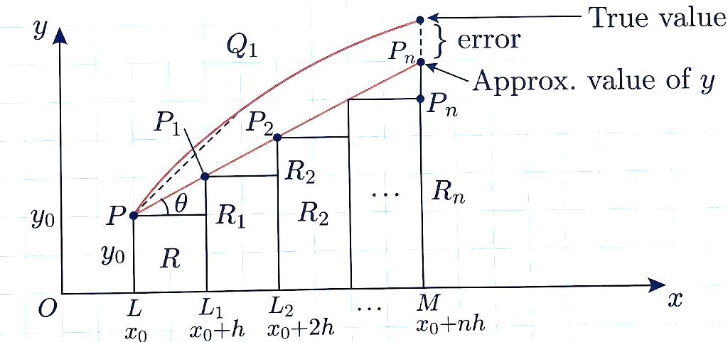
Figure: Illustration of Euler's Method (1st Order RK-Method)

Let us divide $x_{0}$ to $x_{n}$ into $n$ sub-intervals each of width $h$ at $x_{1},x_{2},…$ so that $h$ is quite small. In the interval $x_{0},x_{1}$ we approximate the curve by the tangent at $P(x_{0},y_{0})$; the ordinate through $x_{1}$ meets this tangent in $P_{1}(x_{0}+h,y_{1})$, then
$$y_{1}=y_{0}+h{\left(\frac{dy}{dx}\right)}_{P}=y_{0}+hf(x_{0},y_{0})$$
Let $P_{1}$ be the curve of solution through $P_{1}$ and let its tangent at $P_{1}$ meet the ordinate through $x_{2}$ in $P_{2}(x_{0}+2h,y_{2})$. Then
$$y_{2}=y_{1}+hf(x_{0}+h,y_{1})(1)$$
Repeating this process $n$ times, we finally reach an approximation $P_{n}$ of $M_{0}$ given by
$$y_{n}=y_{n-1}+hf(x_{0}+(n-1)h,y_{n-1})$$
This is Euler's Method of Finding an Approximate Solution of (1).
Observation:
In Euler's Method, we approximate the curve of solution by the tangent in each interval, i.e., by a sequence of short lines. Unless $h$ is small, the error is bound to be quite significant. This sequence of lines may also deviate considerably from the curve of solution. As such, the method is very slow and hence there is a modification of this method which is given below.
Python Code:
"""
Euler's Method for solving ODE: dy/dx = f(x, y)
Given: y(x0) = y0
"""

import math

def euler_method(f, x0, y0, h, x_target):
"""
Solve ODE using Euler's Method

Parameters:
f: function f(x, y) = dy/dx
x0, y0: initial conditions
h: step size
x_target: point where solution is desired
"""
print("\n" + "="*70)
print("EULER'S METHOD")
print("="*70)
print(f"Initial condition: y({x0}) = {y0}")
print(f"Step size: h = {h}")
print(f"Target: x = {x_target}")
print("-"*70)
print(f"{'x':<12}{'y':<12}{'dy/dx':<12}{'y_new':<12}")
print("-"*70)

x = x0
y = y0
steps = int((x_target - x0) / h)

for step in range(steps):
dy = f(x, y)
y_new = y + h * dy
print(f"{x:<12.4f}{y:<12.6f}{dy:<12.6f}{y_new:<12.6f}")
x = x + h
y = y_new

print("-"*70)
print(f"Result: y({x_target}) = {y:.6f}")
return y

# Example usage
if __name__ == "__main__":
# Example 1: dy/dx = x + y, y(0) = 1, find y(1)
def f1(x, y):
return x + y

print("\nExample 1: dy/dx = x + y, y(0) = 1")
euler_method(f1, 0, 1, 0.1, 1)

# Example 2: dy/dx = (y - x)/(y + x), y(0) = 1, find y(0.1)
def f2(x, y):
return (y - x) / (y + x)

print("\nExample 2: dy/dx = (y-x)/(y+x), y(0) = 1")
euler_method(f2, 0, 1, 0.02, 0.1)

Output:
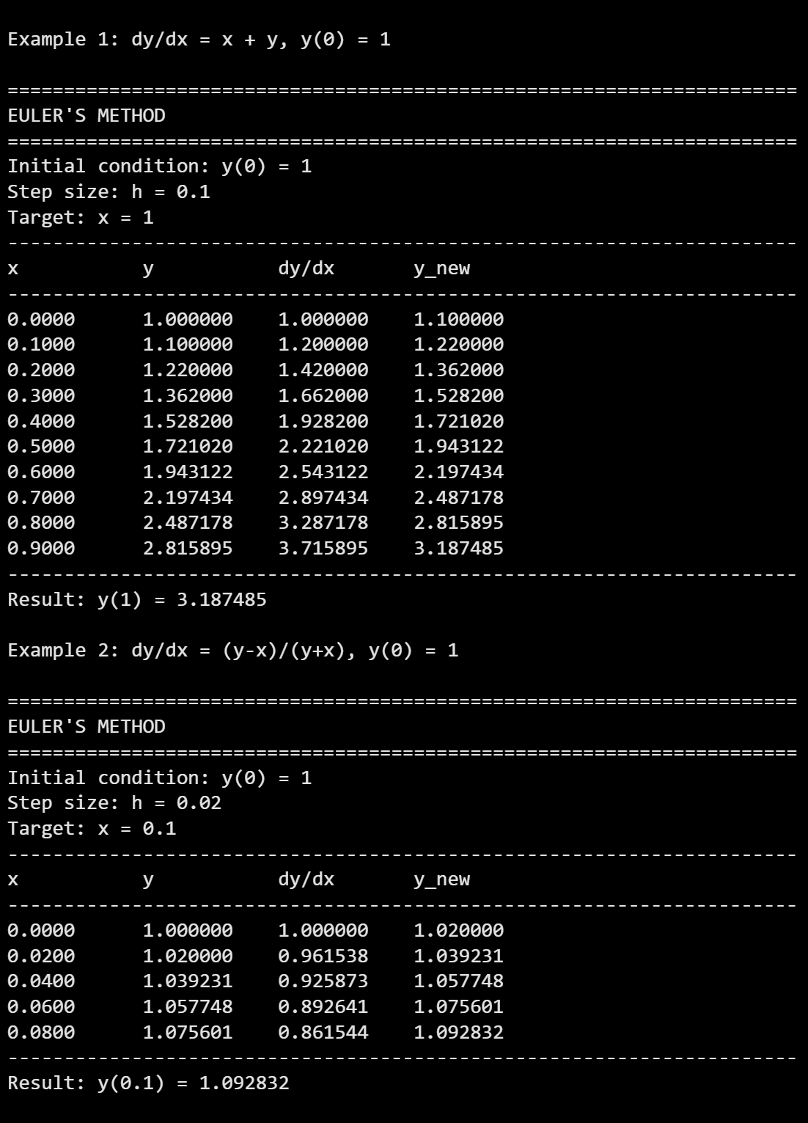
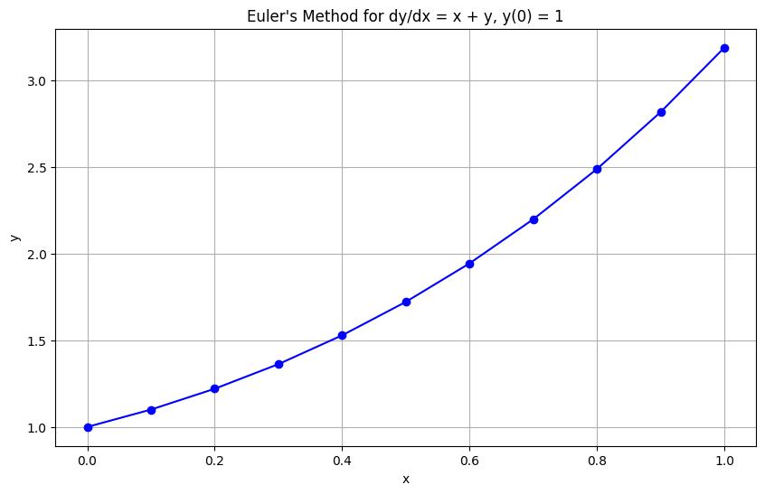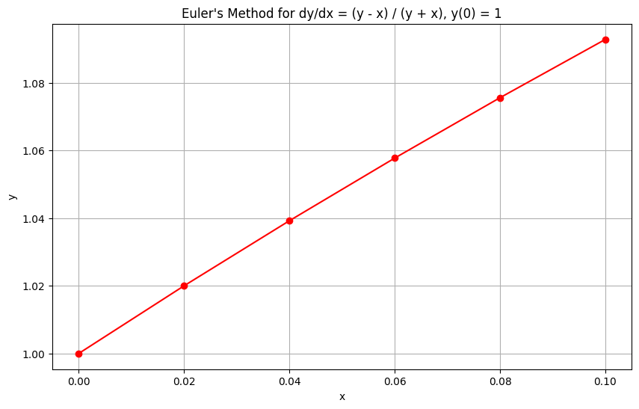

Modified Euler's Method
Euler's Method (1st order RK-Method):
$$\text{New value}=\text{Old value}+(\text{Slope}×\text{Step size}) \\ \text{i.e., New value}=y+\left(\frac{dy}{dx} ⋅ h\right)$$

Example:
Using Euler's Method, find an approximate value of $y$ corresponding to $x=1$, given that $\frac{dy}{dx}=x+y$ and $y=1$ when $x=0$.
Solution:
We take $n=10$ and $h=0.1$ which is sufficiently small. The various calculations are arranged as follows:
$$x$$ | $$y$$ | $$x+y=\frac{dy}{dx}$$ | $$y+0.1\left(\frac{dy}{dx}\right)$$ | = new $y$
0.0 | 1.00 | 1.00 | 1.00 + 0.1(1.00) = 1.10 | 1.10
0.1 | 1.10 | 1.20 | 1.10 + 0.1(1.20) = 1.22 | 1.22
0.2 | 1.22 | 1.42 | 1.22 + 0.1(1.42) = 1.36 | 1.36
0.3 | 1.36 | 1.66 | 1.36 + 0.1(1.66) = 1.53 | 1.53
0.4 | 1.53 | 1.93 | 1.53 + 0.1(1.93) = 1.72 | 1.72
0.5 | 1.72 | 2.22 | 1.72 + 0.1(2.22) = 1.94 | 1.94
0.6 | 1.94 | 2.54 | 1.94 + 0.1(2.54) = 2.19 | 2.19
0.7 | 2.19 | 2.89 | 2.19 + 0.1(2.89) = 2.48 | 2.48
0.8 | 2.48 | 3.29 | 2.48 + 0.1(3.29) = 2.81 | 2.81
0.9 | 2.81 | 3.71 | 2.81 + 0.1(3.71) = 3.18 | 3.18
Thus the required approximate value of $y$ when $x=1$ is $3.18$.

Example:
Given $\frac{dy}{dx}=\frac{y-x}{y+x}$ with initial condition $y=1$ at $x=0$. Find $y$ for $x=0.1$ by Euler's Method.
Solution:
We divide the interval (0, 0.1) into five steps, i.e., we take $n=5$ and $h=0.02$. The various calculations are arranged as follows:

$$x$$ | $$y$$ | $$f(x,y)$$ | $$y+hf(x,y)$$
0.00 | 1.0000 | 1.0000 | 1.0200
0.02 | 1.0200 | 0.9615 | 1.0392
0.04 | 1.0392 | 0.926 | 1.0577
0.06 | 1.0577 | 0.893 | 1.0756
0.08 | 1.0756 | 0.862 | 1.0928
0.10 | 1.0928
Hence the required approximate value of $y$ at $x=0.1$ is $1.0928$.

Python Code:

import math

def modified_euler(f, x0, y0, h, x_target):
"""
Solve ODE using Modified Euler's Method (RK2)

Parameters:
f: function f(x, y) = dy/dx
x0, y0: initial conditions
h: step size
x_target: point where solution is desired
"""
print("\n" + "="*70)
print("MODIFIED EULER'S METHOD (RK-2 / HEUN'S METHOD)")
print("="*70)
print(f"Initial condition: y({x0}) = {y0}")
print(f"Step size: h = {h}")
print(f"Target: x = {x_target}")
print("-"*70)
print(f"{'x':<12}{'y':<12}{'k1':<12}{'k2':<12}{'y_next':<12}")
print("-"*70)

x = x0
y = y0
steps = int((x_target - x0) / h)

for step in range(steps):
k1 = h * f(x, y)
k2 = h * f(x + h, y + k1)
y_next = y + 0.5 * (k1 + k2)

print(f"{x:<12.4f}{y:<12.6f}{k1:<12.6f}{k2:<12.6f}{y_next:<12.6f}")

x = x + h
y = y_next

print("-"*70)
print(f"Result: y({x_target}) = {y:.6f}")
return y

# Example usage
if __name__ == "__main__":
# Example: dy/dx = x + y, y(0) = 1, find y(0.2)
def f(x, y):
return x + y

modified_euler(f, 0, 1, 0.1, 0.2)
Output:
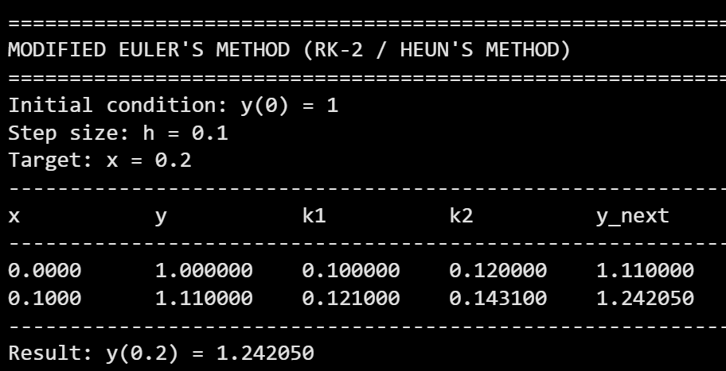
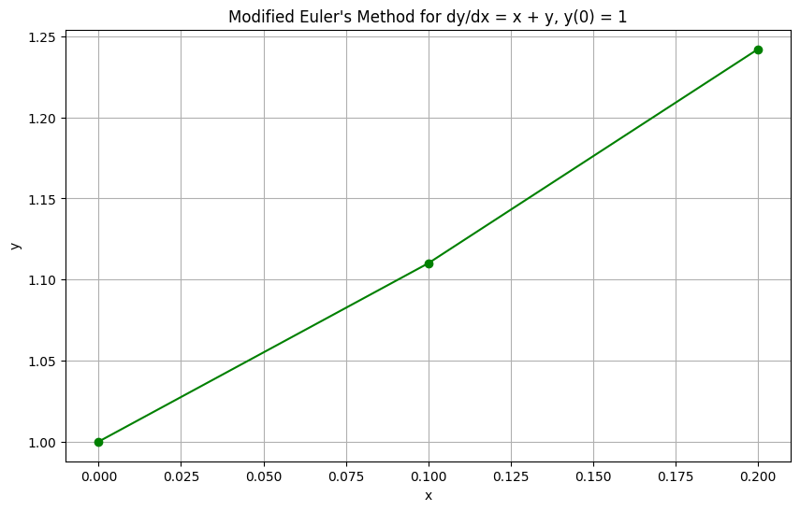

Runge-Kutta Second Order (RK-2) Method
Also known as the modified Euler method or Heun's method.
$$\begin{matrix}k_{1} & =hf(x_{n},y_{n}) \\ k_{2} & =hf(x_{n}+h,y_{n}+k_{1}) \\ y_{n+1} & =y_{n}+\frac{1}{2}(k_{1}+k_{2})\end{matrix}$$
Example:
Step 1:
$$x_{0}=0,y_{0}=1.5,h=0.2 \\ k_{1}=hf(x_{0},y_{0})=0.29665$$$k_{2}=hf(x_{0}+h,y_{0}+k_{1})=0.29665$ (approx)
$$k=\frac{k_{1}+k_{2}}{2}=0.29665 \\ x_{1}=x_{0}+h=0.2 \\ y_{1}=y_{0}+k=1.79665$$
Step 2:
$$x_{0}=0.2,y_{0}=1.79665,h=0.2 \\ k_{1}=hf(x_{0},y_{0})=0.29255 \\ k_{2}=hf(0.4,2.0892)=0.2\left[\frac{\left(2.0892)^{2}-3(0.4\right)}{2.0892}\right]=0.30298 \\ k=\frac{0.29255+0.30298}{2}=0.29777 \\ x_{1}=0.4,y_{1}=2.09442$$
Step 3:
$$k_{1}=0.3043,k_{2}=0.32969,k=0.3170 \\ x_{1}=0.6,y_{1}=2.4115$$
Hence the required approximate value of $y$ when $x=0.6$ is $2.4115$.

Runge-Kutta Fourth Order Method (RK4 / Classical RK Method)
Consider the equation
$$\frac{dy}{dx}=f(x,y),y(x_{0})=y_{0}$$
Step size = $h$. Then,
$$\begin{matrix}k_{1} & =hf(x_{0},y_{0}) \\ k_{2} & =hf\left(x_{0}+\frac{h}{2},y_{0}+\frac{k_{1}}{2}\right) \\ k_{3} & =hf\left(x_{0}+\frac{h}{2},y_{0}+\frac{k_{2}}{2}\right) \\ k_{4} & =hf\left(x_{0}+h,y_{0}+k_{3}\right) \\ k & =\frac{k_{1}+2k_{2}+2k_{3}+k_{4}}{6}\end{matrix}$$
Then,
$$x_{1}=x_{0}+h,y_{1}=y_{0}+k$$

Example
Apply Runge-Kutta fourth order Method to find an approximate value of $y$ when $x=0.2$ given that $\frac{dy}{dx}=x+y$ and $y=1$ when $x=0$.
Solution:
$$x_{0}=0,y_{0}=1,h=0.2,f(x,y)=x+y \\ k_{1}=0.2f(0,1)=0.2(1)=0.2 \\ k_{2}=0.2f(0.1,1.1)=0.2(1.2)=0.24 \\ k_{3}=0.2f(0.1,1.12)=0.2(1.22)=0.244 \\ k_{4}=0.2f(0.2,1.244)=0.2(1.444)=0.2888 \\ k=\frac{0.2+2(0.24)+2(0.244)+0.2888}{6}=\frac{1.4568}{6}=0.2428 \\ y(0.2)=1+0.2428=1.2428$$

Example:
Apply Runge-Kutta Method to find approximate value of $y$ for $x=0.2$ in steps of $0.1$ if $\frac{dy}{dx}=x+y^{2}$, given that $y=1$ when $x=0$.
Solution:
$f(x,y)=x+y^{2}$, $h=0.1$
Step 1: $x_{0}=0,y_{0}=1$
$$k_{1}=0.1(0+1)=0.1 \\ k_{2}=0.1(0.05+(1.05)^{2})=0.1(0.05+1.1025)=0.11525 \\ k_{3}=0.1(0.05+(1.057625)^{2})≈0.1168 \\ k_{4}=0.1(0.1+(1.1168)^{2})≈0.1347 \\ k=\frac{0.1+2(0.11525)+2(0.1168)+0.1347}{6}≈0.1153 \\ y(0.1)=1.1153$$
Step 2: Continue similarly to get $y(0.2)$.
Python Code:
"""
Runge-Kutta 4th Order Method for solving ODE: dy/dx = f(x, y)
Given: y(x0) = y0
"""

import math

def rk4(f, x0, y0, h, x_target):
"""
Solve ODE using 4th Order Runge-Kutta Method

Parameters:
f: function f(x, y) = dy/dx
x0, y0: initial conditions
h: step size
x_target: point where solution is desired
"""
print("\n" + "="*70)
print("RUNGE-KUTTA 4TH ORDER METHOD (RK4)")
print("="*70)
print(f"Initial condition: y({x0}) = {y0}")
print(f"Step size: h = {h}")
print(f"Target: x = {x_target}")
print("-"*70)
print(f"{'x':<12}{'y':<12}{'k1':<12}{'k2':<12}{'k3':<12}{'k4':<12}{'y_next':<12}")
print("-"*70)

x = x0
y = y0
steps = int((x_target - x0) / h)

for step in range(steps):
k1 = h * f(x, y)
k2 = h * f(x + h/2, y + k1/2)
k3 = h * f(x + h/2, y + k2/2)
k4 = h * f(x + h, y + k3)

y_next = y + (k1 + 2*k2 + 2*k3 + k4) / 6

print(f"{x:<12.4f}{y:<12.6f}{k1:<12.6f}{k2:<12.6f}{k3:<12.6f}{k4:<12.6f}{y_next:<12.6f}")

x = x + h
y = y_next

print("-"*70)
print(f"Result: y({x_target}) = {y:.6f}")
return y

# Example usage
if __name__ == "__main__":
# Example 1: dy/dx = x + y, y(0) = 1, find y(0.2)
def f1(x, y):
return x + y

print("\nExample 1: dy/dx = x + y, y(0) = 1")
rk4(f1, 0, 1, 0.2, 0.2)

# Example 2: dy/dx = x + y^2, y(0) = 1, find y(0.2) with h=0.1
def f2(x, y):
return x + y**2

print("\nExample 2: dy/dx = x + y^2, y(0) = 1")
rk4(f2, 0, 1, 0.1, 0.2)
Output:
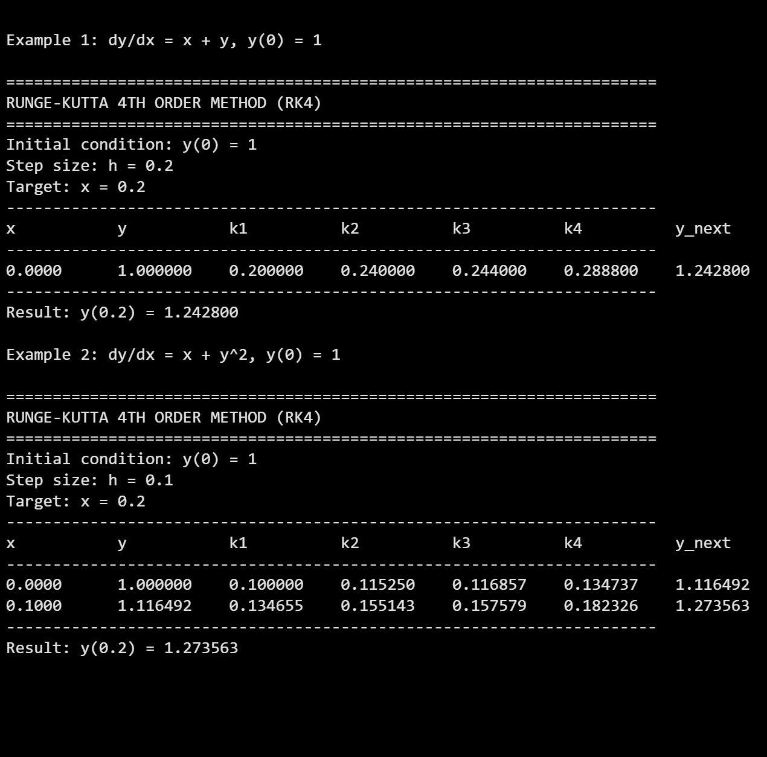

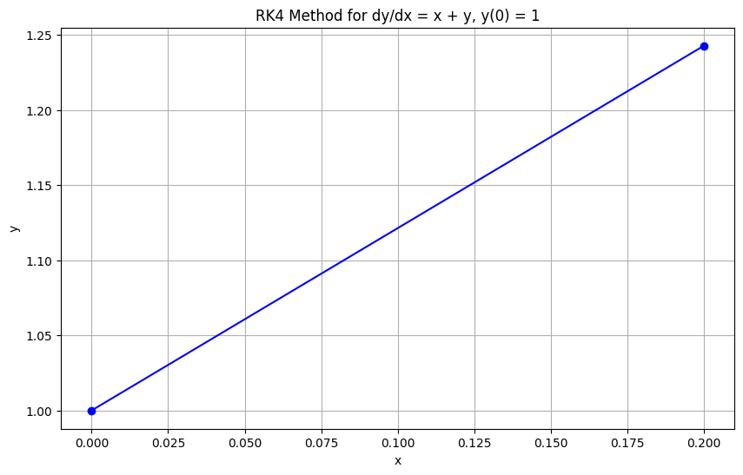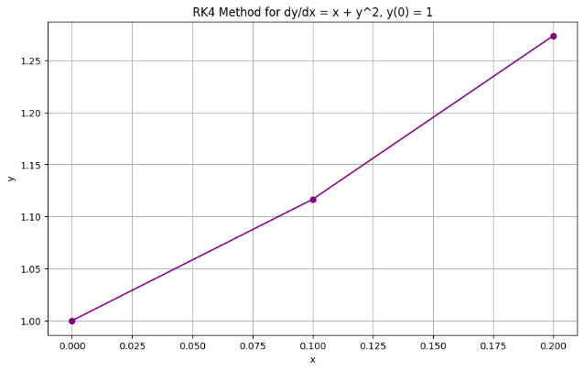

5.1.2 Solution of System of First Order ODEs via Runge-Kutta Methods
Given:
$$\frac{dy}{dx}=f(x,y,z),\frac{dz}{dx}=g(x,y,z),y(x_{0})=y_{0},z(x_{0})=z_{0}$$
Using RK-4:
$$\begin{matrix}k_{1} & =hf(x_{n},y_{n},z_{n}) \\ l_{1} & =hg(x_{n},y_{n},z_{n}) \\ k_{2} & =hf(x_{n}+\frac{h}{2},y_{n}+\frac{k_{1}}{2},z_{n}+\frac{l_{1}}{2}) \\ l_{2} & =hg(x_{n}+\frac{h}{2},y_{n}+\frac{k_{1}}{2},z_{n}+\frac{l_{1}}{2}) \\ k_{3} & =hf(x_{n}+\frac{h}{2},y_{n}+\frac{k_{2}}{2},z_{n}+\frac{l_{2}}{2}) \\ l_{3} & =hg(x_{n}+\frac{h}{2},y_{n}+\frac{k_{2}}{2},z_{n}+\frac{l_{2}}{2}) \\ k_{4} & =hf(x_{n}+h,y_{n}+k_{3},z_{n}+l_{3}) \\ l_{4} & =hg(x_{n}+h,y_{n}+k_{3},z_{n}+l_{3}) \\ y_{n+1} & =y_{n}+\frac{1}{6}(k_{1}+2k_{2}+2k_{3}+k_{4}) \\ z_{n+1} & =z_{n}+\frac{1}{6}(l_{1}+2l_{2}+2l_{3}+l_{4})\end{matrix}$$

Example:
Solve $\frac{dy}{dx}=yz+x$, $\frac{dz}{dx}=xy+z$, given $y(0)=1,z(0)=-1$ for $y(0.2),z(0.2)$ using RK4 with $h=0.2$.
Solution:
$f(x,y,z)=yz+x$, $g(x,y,z)=xy+z$
$$x_{0}=0,y_{0}=1,z_{0}=-1,h=0.2$$
$$k_{1}=hf(0,1,-1)=0.2(-1)=-0.2 \\ l_{1}=hg(0,1,-1)=0.2(-1)=-0.2$$
$$k_{2}=hf(0.1,1+(-0.1),-1+(-0.1))=0.2f(0.1,0.9,-1.1)=0.2(0.9×-1.1+0.1)=0.2(-0.89)=-0.178 \\ l_{2}=hg(0.1,0.9,-1.1)=0.2(0.9×0.1+(-1.1))=0.2(-1.01)=-0.202$$
$$k_{3}=hf(0.1,1+(-0.089),-1+(-0.101))=0.2f(0.1,0.911,-1.101)=0.2(0.911×-1.101+0.1)=0.2(-0.902)=-0.1804 \\ l_{3}=hg(0.1,0.911,-1.101)=0.2(0.911×0.1+(-1.101))=0.2(-1.0099)=-0.20198$$
$$k_{4}=hf(0.2,1+(-0.1804),-1+(-0.20198))=0.2f(0.2,0.8196,-1.20198)=0.2(0.8196×-1.20198+0.2)=0.2(-0.784)=-0.1568 \\ l_{4}=hg(0.2,0.8196,-1.20198)=0.2(0.8196×0.2+(-1.20198))=0.2(-1.038)=-0.2076$$
$$k=\frac{-0.2+2(-0.178)+2(-0.1804)+(-0.1568)}{6}=\frac{-1.0736}{6}=-0.17893 \\ l=\frac{-0.2+2(-0.202)+2(-0.20198)+(-0.2076)}{6}=\frac{-1.21556}{6}=-0.20259$$
Thus,
$$x_{1}=0.2 \\ y_{1}=1+(-0.17893)=0.82107 \\ z_{1}=-1+(-0.20259)=-1.20259$$
Hence $y(0.2)=0.821$, $z(0.2)=-1.203$.
Python code:
"""
Runge-Kutta 4th Order Method for System of First Order ODEs
dy/dx = f(x, y, z)
dz/dx = g(x, y, z)
Given: y(x0) = y0, z(x0) = z0
"""

import math

def rk4_system(f, g, x0, y0, z0, h, x_target):
"""
Solve system of ODEs using RK4 Method

Parameters:
f: function f(x, y, z) = dy/dx
g: function g(x, y, z) = dz/dx
x0, y0, z0: initial conditions
h: step size
x_target: point where solution is desired
"""
print("\n" + "="*70)
print("RK4 METHOD FOR SYSTEM OF FIRST ORDER ODES")
print("="*70)
print(f"Initial conditions: y({x0}) = {y0}, z({x0}) = {z0}")
print(f"Step size: h = {h}")
print(f"Target: x = {x_target}")
print("-"*70)
print(f"{'x':<10}{'y':<12}{'z':<12}{'k1/l1':<12}{'k2/l2':<12}{'k3/l3':<12}{'k4/l4':<12}")
print("-"*70)

x = x0
y = y0
z = z0
steps = int((x_target - x0) / h)

for step in range(steps):
# Calculate k1, l1
k1 = h * f(x, y, z)
l1 = h * g(x, y, z)

# Calculate k2, l2
k2 = h * f(x + h/2, y + k1/2, z + l1/2)
l2 = h * g(x + h/2, y + k1/2, z + l1/2)

# Calculate k3, l3
k3 = h * f(x + h/2, y + k2/2, z + l2/2)
l3 = h * g(x + h/2, y + k2/2, z + l2/2)

# Calculate k4, l4
k4 = h * f(x + h, y + k3, z + l3)
l4 = h * g(x + h, y + k3, z + l3)

# Compute next values
y_next = y + (k1 + 2*k2 + 2*k3 + k4) / 6
z_next = z + (l1 + 2*l2 + 2*l3 + l4) / 6

print(f"{x:<10.4f}{y:<12.6f}{z:<12.6f}{k1:<12.6f}{k2:<12.6f}{k3:<12.6f}{k4:<12.6f}")

x = x + h
y = y_next
z = z_next

print("-"*70)
print(f"Results at x = {x_target}:")
print(f" y = {y:.6f}")
print(f" z = {z:.6f}")
return y, z

# Example usage
if __name__ == "__main__":
# Example: dy/dx = yz + x, dz/dx = xy + z
# Given: y(0) = 1, z(0) = -1, find y(0.2), z(0.2) with h=0.2

def f(x, y, z):
return y * z + x

def g(x, y, z):
return x * y + z

rk4_system(f, g, 0, 1, -1, 0.2, 0.2)
Output:
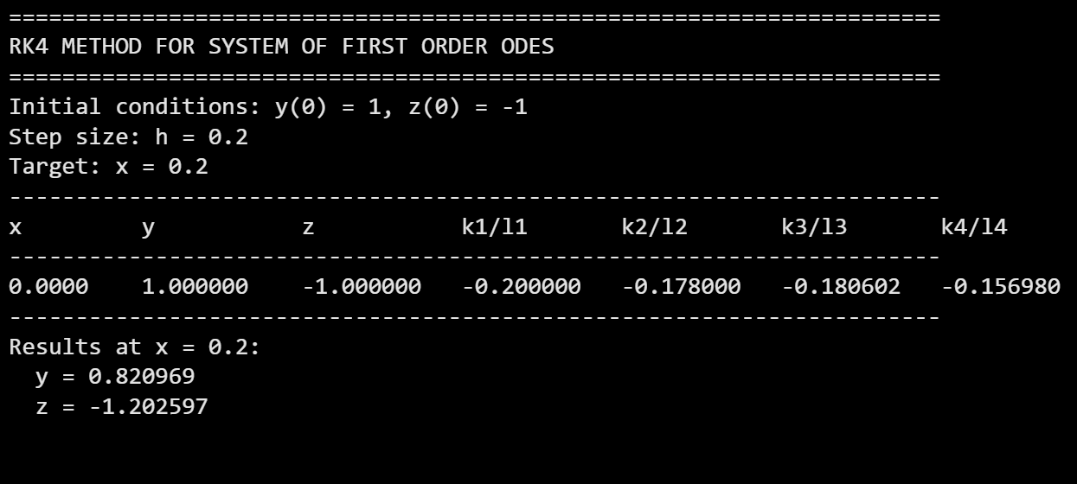

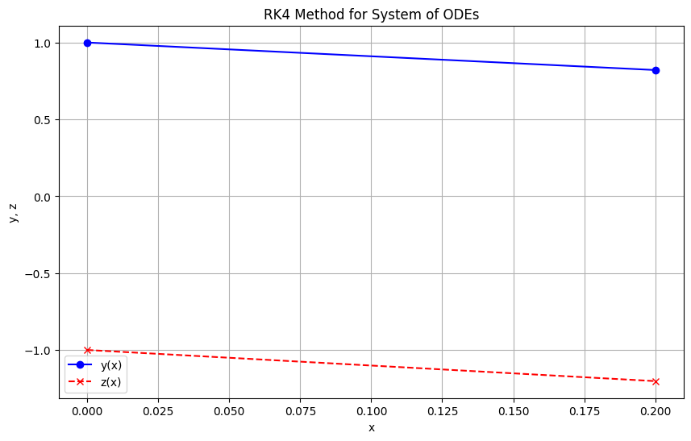

5.1.3 Solution of Second Order ODEs via Runge-Kutta Methods
A second order ODE:
$$\frac{d^{2}y}{dx^{2}}=F\left(x , y , \frac{dy}{dx}\right)$$
is reduced to a system of first order ODEs by letting:
$$\frac{dy}{dx}=z,\frac{dz}{dx}=F(x,y,z)$$
Then solve the system using RK-4 (as in section 5.1.2).

Example:
Solve $\frac{d^{2}y}{dx^{2}}+\frac{dy}{dx}-4y=3x$ with $y(0)=0$ and $y^{'}(0)=1$ using RK-4 method with $h=0.5$ within $0≤x≤1.0$.
Solution:
Let $y_{1}=y$ and $z=\frac{dy}{dx}$. Then the given equation becomes:
$$\frac{dz}{dx}=3x+4y-z=g(x,y,z) \\ \frac{dy}{dx}=z=f(x,y,z)$$
Given: $x_{0}=0,y_{0}=0,z_{0}=1,h=0.5$
Step 1:
$$\begin{matrix}m_{1} & =f(x_{0},y_{0},z_{0})=z_{0}=1 \\ k_{1} & =g(x_{0},y_{0},z_{0})=3(0)+4(0)-1=-1 \\ m_{2} & =f\left(x_{0}+\frac{h}{2},y_{0}+\frac{m_{1}h}{2},z_{0}+\frac{k_{1}h}{2}\right)=f(0.25,0.25,0.75)=0.75 \\ k_{2} & =g(0.25,0.25,0.75)=3(0.25)+4(0.25)-0.75=1 \\ m_{3} & =f(0.25,0.25+0.75×0.25,0.75+1×0.25)=f(0.25,0.4375,1.0)=1.0 \\ k_{3} & =g(0.25,0.4375,1.0)=0.75+1.75-1.0=1.5 \\ m_{4} & =f(0.5,0+1.0×0.5,1+1.5×0.5)=f(0.5,0.5,1.75)=1.75 \\ k_{4} & =g(0.5,0.5,1.75)=1.5+2.0-1.75=1.75\end{matrix} \\ m=\frac{m_{1}+2m_{2}+2m_{3}+m_{4}}{6}=\frac{1+2(0.75)+2(1.0)+1.75}{6}=\frac{1+1.5+2+1.75}{6}=\frac{6.25}{6}=1.0417 \\ k=\frac{k_{1}+2k_{2}+2k_{3}+k_{4}}{6}=\frac{-1+2(1)+2(1.5)+1.75}{6}=\frac{-1+2+3+1.75}{6}=\frac{5.75}{6}=0.9583$$
Thus,
$x_{1}=0.5$, $y_{1}=0+(1.0417)(0.5)=0.52085$, $z_{1}=1+(0.9583)(0.5)=1.47915$
Step 2: Similarly proceed to $x=1.0$.
Python Code:
"""
Solving Second Order ODEs using RK4 Method
Convert second order ODE to system of first order ODEs
d²y/dx² = F(x, y, dy/dx)
"""

import math

def rk4_second_order(F, x0, y0, dy0, h, x_target):
"""
Solve second order ODE using RK4 Method

Parameters:
F: function F(x, y, dy/dx) = d²y/dx²
x0, y0, dy0: initial conditions y(x0)=y0, y'(x0)=dy0
h: step size
x_target: point where solution is desired
"""
print("\n" + "="*70)
print("RK4 METHOD FOR SECOND ORDER ODE")
print("="*70)
print(f"Initial conditions: y({x0}) = {y0}, y'({x0}) = {dy0}")
print(f"Step size: h = {h}")
print(f"Target: x = {x_target}")
print("-"*70)
print(f"{'x':<10}{'y':<12}{'dy/dx':<12}{'m1/k1':<12}{'m2/k2':<12}{'m3/k3':<12}{'m4/k4':<12}")
print("-"*70)

x = x0
y = y0
z = dy0 # z = dy/dx
steps = int((x_target - x0) / h)

for step in range(steps):
# For dy/dx = z, we use m-values
m1 = h * z
k1 = h * F(x, y, z)

m2 = h * (z + k1/2)
k2 = h * F(x + h/2, y + m1/2, z + k1/2)

m3 = h * (z + k2/2)
k3 = h * F(x + h/2, y + m2/2, z + k2/2)

m4 = h * (z + k3)
k4 = h * F(x + h, y + m3, z + k3)

# Update
y_next = y + (m1 + 2*m2 + 2*m3 + m4) / 6
z_next = z + (k1 + 2*k2 + 2*k3 + k4) / 6

print(f"{x:<10.4f}{y:<12.6f}{z:<12.6f}{m1:<12.6f}{k1:<12.6f}{'':<12}{'':<12}")
print(f"{'':<10}{'':<12}{'':<12}{m2:<12.6f}{k2:<12.6f}{m3:<12.6f}{k3:<12.6f}")
print(f"{'':<10}{'':<12}{'':<12}{m4:<12.6f}{k4:<12.6f}{'':<12}{'':<12}")

x = x + h
y = y_next
z = z_next

print(f" → x={x:.4f}, y={y:.6f}, y'={z:.6f}")
print("-"*70)

print(f"Result at x = {x_target}:")
print(f" y = {y:.6f}")
print(f" y' = {z:.6f}")
return y, z

# Example usage
if __name__ == "__main__":
# Example: d²y/dx² + dy/dx - 4y = 3x
# Given: y(0) = 0, y'(0) = 1
# Rearranged: d²y/dx² = 3x + 4y - dy/dx

def F(x, y, dy):
return 3*x + 4*y - dy

rk4_second_order(F, 0, 0, 1, 0.5, 1.0)
Output:
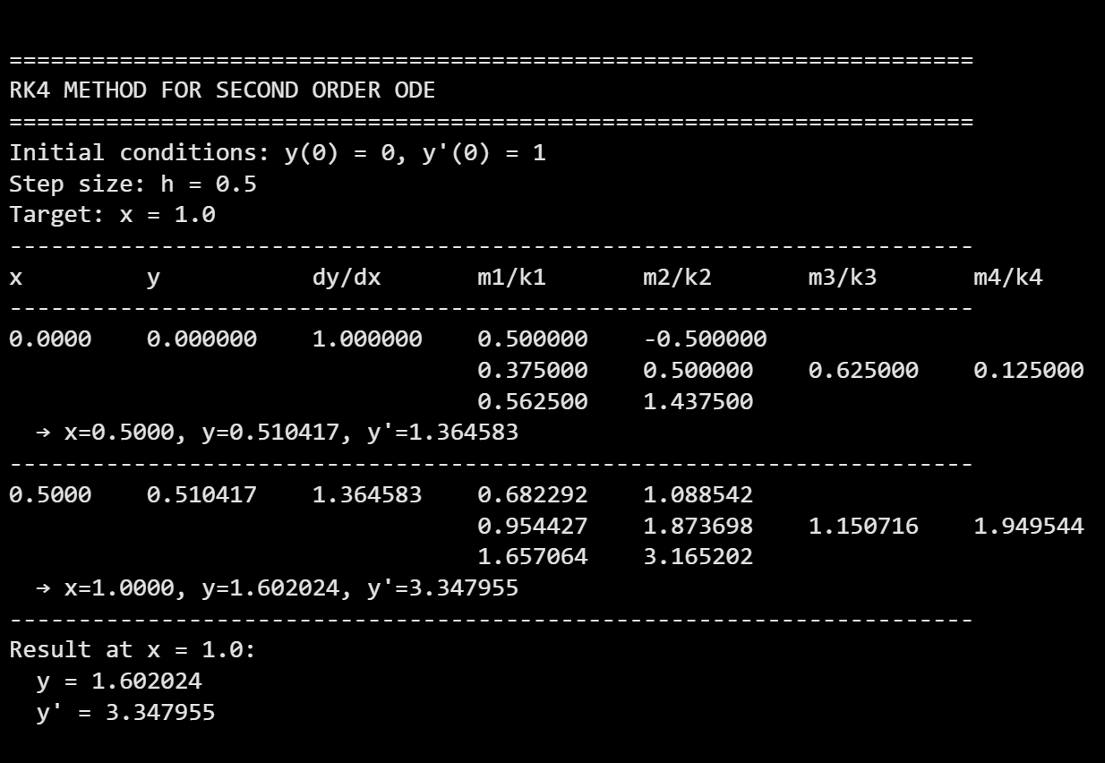

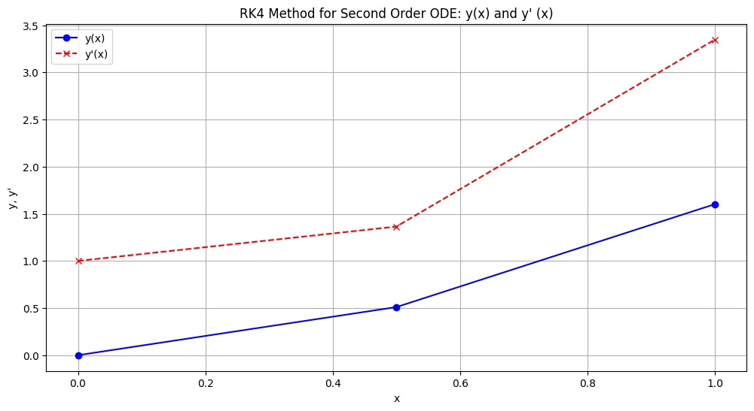

5.2 Two-Point Boundary Value Problems
This method transforms a boundary value problem into an initial value problem by guessing the missing initial condition (slope), solving, and adjusting the guess until the boundary condition at the end is satisfied.
The method is called the Shooting Method because it resembles an artillery problem.
Consider the equation:
$$\frac{d^{2}y}{dx^{2}}=f\left(x , y , \frac{dy}{dx}\right)\text{with}y(a)=A\text{and}y(b)=B$$
In this method, the given boundary value problem is first transformed into an initial value problem. Then this initial value problem is solved by a Runge-Kutta method. Finally, the given boundary value problem is solved. The method is quite simple.
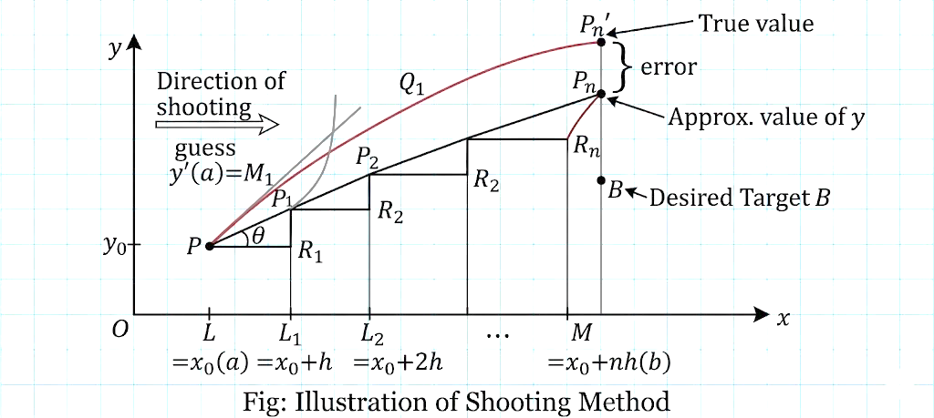
Figure: Illustration of Shooting Method

Algorithm:
- Convert the BVP into an IVP by guessing the missing initial condition, say $y^{'}(a)=m$.
- Solve the IVP using a numerical method (e.g., RK-4) to find $y(b)$.
- If $y(b)≠$ given boundary condition, adjust $m$ using interpolation or Newton's method.
- Repeat until convergence.

Example:
Solve using the Shooting Method for
$$\frac{d^{2}y}{dx^{2}}=6x,y(1)=2,y(2)=9$$
Solution:
Let $z=\frac{dy}{dx}$. Then $\frac{dz}{dx}=6x$, with $y(1)=2$, $y(2)=9$. We guess $z(1)=m$.
First guess: $z(1)=2$
Integrate: $z(x)=3x^{2}+C$
$$2=3(1)^{2}+C⇒C=-1$$So $z(x)=3x^{2}-1$
Now $\frac{dy}{dx}=z=3x^{2}-1$
$$y(x)=x^{3}-x+D \\ 2=1-1+D⇒D=2$$So $y(x)=x^{3}-x+2$
At $x=2$: $y(2)=8-2+2=8$ (Error = -1)
Second guess: $z(1)=4$
$$4=3(1)^{2}+C⇒C=1 \\ z(x)=3x^{2}+1 \\ y(x)=x^{3}+x+D \\ 2=1+1+D⇒D=0 \\ y(x)=x^{3}+x$$At $x=2$: $y(2)=8+2=10$ (Error = +1)
Linear interpolation to find better guess:
Let $m_{1}=2$ give $y_{1}(2)=8$
Let $m_{2}=4$ give $y_{2}(2)=10$
We want $y(2)=9$.
Using interpolation formula:
$$m=m_{1}+\frac{9-y_{1}(2)}{y_{2}(2)-y_{1}(2)}×(m_{2}-m_{1}) \\ m=2+\frac{9-8}{10-8}×(4-2)=2+\frac{1}{2}×2=3$$
Check guess: $z(1)=3$
$$3=3(1)^{2}+C⇒C=0 \\ z(x)=3x^{2} \\ y(x)=x^{3}+D \\ 2=1+D⇒D=1 \\ y(x)=x^{3}+1$$At $x=2$: $y(2)=8+1=9$ ✓
Thus the required solution is:
$$\boxed{y(x)=x^{3}+1}$$

Example with Heun's method:
Using shooting method, solve $\frac{dz}{dx}=6x$, $\frac{dy}{dx}=z$ in the interval (1,2).
Step 1: $h=0.5$, $x_{0}=1$, $y(1)=2$
Assume $z(1)=y^{'}(1)=2$ (First guess)
Applying Heun's method: $h=0.5$, $x_{0}=1$, $y_{0}=2$, $z_{0}=2$
$$m_{1}=f(x_{0},y_{0},z_{0})=z=2 \\ k_{1}=g(x_{0},y_{0},z_{0})=6⋅1=6$$
After iterations, final guess $z(1)=3.25$ gives $y(2)=9$.

Python code:
"""
Shooting Method for solving Boundary Value Problems
d²y/dx² = f(x, y, dy/dx) with y(a) = A, y(b) = B
"""

import math

def shooting_method(F, a, b, A, B, h, tol=1e-6, max_iter=10):
"""
Solve BVP using Shooting Method with RK4

Parameters:
F: function F(x, y, dy/dx) = d²y/dx²
a, b: boundaries
A, B: boundary conditions y(a)=A, y(b)=B
h: step size
tol: tolerance
max_iter: maximum iterations
"""
print("\n" + "="*70)
print("SHOOTING METHOD FOR BOUNDARY VALUE PROBLEMS")
print("="*70)
print(f"Boundary conditions: y({a}) = {A}, y({b}) = {B}")
print(f"Step size: h = {h}")
print("-"*70)

def solve_ivp(guess):
"""Solve IVP with given initial slope guess"""
x = a
y = A
z = guess # dy/dx at x=a

n_steps = int((b - a) / h)

for _ in range(n_steps):
# RK4 for system
m1 = h * z
k1 = h * F(x, y, z)

m2 = h * (z + k1/2)
k2 = h * F(x + h/2, y + m1/2, z + k1/2)

m3 = h * (z + k2/2)
k3 = h * F(x + h/2, y + m2/2, z + k2/2)

m4 = h * (z + k3)
k4 = h * F(x + h, y + m3, z + k3)

y = y + (m1 + 2*m2 + 2*m3 + m4) / 6
z = z + (k1 + 2*k2 + 2*k3 + k4) / 6
x = x + h

return y # y(b)

# Shooting iterations
print(f"\n{'Iteration':<10}{'Slope Guess':<15}{'y(b) Computed':<15}{'Error':<15}")
print("-"*70)

# First guess
m1 = (B - A) / (b - a) # linear interpolation guess
yb1 = solve_ivp(m1)
error1 = yb1 - B

print(f"{1:<10}{m1:<15.6f}{yb1:<15.6f}{error1:<15.6f}")

# Second guess
m2 = m1 + 1.0
yb2 = solve_ivp(m2)
error2 = yb2 - B

print(f"{2:<10}{m2:<15.6f}{yb2:<15.6f}{error2:<15.6f}")

# Iterate using secant method
for i in range(3, max_iter + 1):
if abs(error2 - error1) < 1e-12:
break

# Secant method to find better guess
m_new = m2 - error2 * (m2 - m1) / (error2 - error1)
yb_new = solve_ivp(m_new)
error_new = yb_new - B

print(f"{i:<10}{m_new:<15.6f}{yb_new:<15.6f}{error_new:<15.6f}")

if abs(error_new) < tol:
print("-"*70)
print(f"Converged! Required slope at x={a} is {m_new:.6f}")
return m_new

# Update for next iteration
m1, m2 = m2, m_new
error1, error2 = error2, error_new

print("-"*70)
print(f"Final slope approximation: {m_new:.6f}")
return m_new

# Example usage
if __name__ == "__main__":
# Example: d²y/dx² = 6x, y(1) = 2, y(2) = 9
def F(x, y, dy):
return 6 * x

shooting_method(F, 1, 2, 2, 9, h=0.5)

Output:
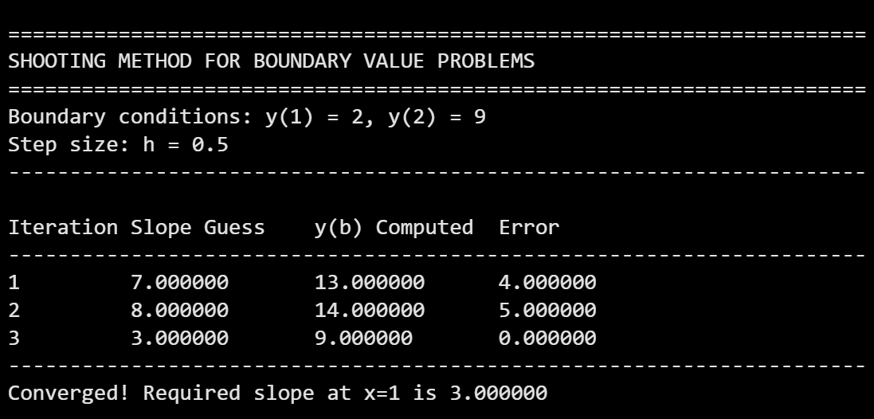
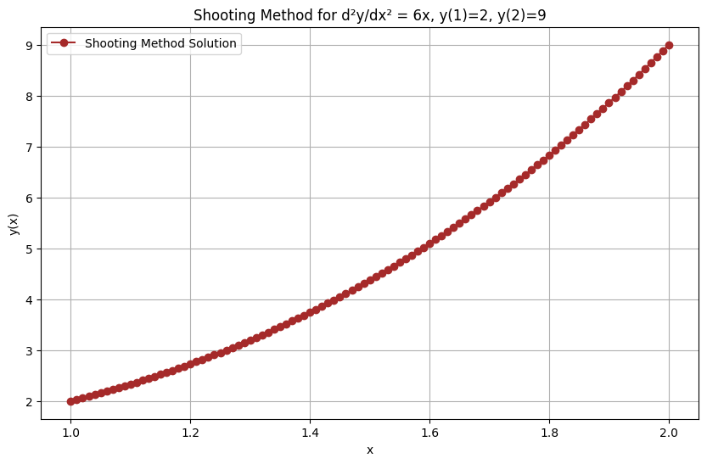

5.2.2 Finite Difference Method
Solution of boundary value problems by finite difference method and shooting method. There are two popular methods available for solving boundary value problems:
- Finite Difference Method
- Shooting Method
In the finite difference method, the derivatives are replaced by their finite difference equivalents, thus converting the differential equation into a system of algebraic equations.
Central difference approximations:
$$y_{i}^{'}=\frac{y_{i+1}-y_{i-1}}{2h},y_{i}^{''}=\frac{y_{i+1}-2y_{i}+y_{i-1}}{h^{2}}$$
Example:
Solve the following boundary value problem using the finite difference method by dividing the interval into 4 sub-intervals.
$$\frac{d^{2}y}{dx^{2}}=x+y,y(0)=y(1)=0$$
Solution:
Given 4 sub-intervals, we have $h=\frac{1-0}{4}=0.25$
$$x_{0}=0,x_{1}=0.25,x_{2}=0.5,x_{3}=0.75,x_{4}=1$$$y_{0}=0,y_{4}=0$. Unknowns: $y_{1},y_{2},y_{3}$.
Using central difference:
$$\frac{y_{i+1}-2y_{i}+y_{i-1}}{h^{2}}=x_{i}+y_{i}$$
Multiply by $h^{2}=0.0625$:
$$y_{i+1}-2y_{i}+y_{i-1}=h^{2}x_{i}+h^{2}y_{i} \\ y_{i+1}-(2+h^{2})y_{i}+y_{i-1}=h^{2}x_{i} \\ y_{i+1}-2.0625y_{i}+y_{i-1}=0.0625x_{i}$$
For $i=1$ ($x_{1}=0.25$):
$$y_{2}-2.0625y_{1}+y_{0}=0.0625×0.25=0.015625$$$y_{2}-2.0625y_{1}=0.015625$ ...(1)
For $i=2$ ($x_{2}=0.5$):
$$y_{3}-2.0625y_{2}+y_{1}=0.0625×0.5=0.03125$$$y_{1}-2.0625y_{2}+y_{3}=0.03125$ ...(2)
For $i=3$ ($x_{3}=0.75$):
$$y_{4}-2.0625y_{3}+y_{2}=0.0625×0.75=0.046875$$$y_{2}-2.0625y_{3}=0.046875$ ...(3)
Solving equations (1), (2), and (3):
From (1): $y_{2}=0.015625+2.0625y_{1}$
From (3): $y_{2}=0.046875+2.0625y_{3}$
Equating: $0.015625+2.0625y_{1}=0.046875+2.0625y_{3}$
$$2.0625y_{1}-2.0625y_{3}=0.03125$$$y_{1}-y_{3}=0.0151515$ ...(4)
From (2), substitute $y_{2}$:
$$y_{1}-2.0625(0.015625+2.0625y_{1})+y_{3}=0.03125 \\ y_{1}-0.0322266-4.25390625y_{1}+y_{3}=0.03125$$$-3.25390625y_{1}+y_{3}=0.0634766$ ...(5)
Solving (4) and (5):
From (4): $y_{3}=y_{1}-0.0151515$
Substitute into (5): $-3.25390625y_{1}+(y_{1}-0.0151515)=0.0634766$
$$-2.25390625y_{1}-0.0151515=0.0634766 \\ -2.25390625y_{1}=0.0786281 \\ y_{1}=-0.03488$$
Then $y_{3}=-0.03488-0.0151515=-0.05003$
$$y_{2}=0.015625+2.0625(-0.03488)=0.015625-0.07193=-0.05631$$
Thus:
$$\boxed{y(0.25)=-0.0349},\boxed{y(0.50)=-0.0563},\boxed{y(0.75)=-0.0500}$$

Example:
Given the equation $\frac{d^{2}y}{dx^{2}}=e^{x^{2}}$ with $y(0)=0$, $y(1)=0$, estimate the values of $y(x)$ at $x=0.25,0.5$ and $0.75$.
Hint:
Using finite difference method:
$$\frac{y_{i+1}-2y_{i}+y_{i-1}}{h^{2}}=e^{x_{i}^{2}}$$
With $h=0.25$, we obtain:
$$\boxed{y(0.25)=-0.1175},\boxed{y(0.50)=-0.1684},\boxed{y(0.75)=-0.1391}$$Python code:
"""
Finite Difference Method for solving Boundary Value Problems
d²y/dx² = f(x, y) with y(a) = A, y(b) = B
"""

import numpy as np

def finite_difference(f, a, b, A, B, n):
"""
Solve BVP using Finite Difference Method

Parameters:
f: function f(x, y) = d²y/dx²
a, b: boundaries
A, B: boundary conditions y(a)=A, y(b)=B
n: number of subintervals
"""
print("\n" + "="*70)
print("FINITE DIFFERENCE METHOD")
print("="*70)
print(f"Boundary conditions: y({a}) = {A}, y({b}) = {B}")
print(f"Number of subintervals: n = {n}")

h = (b - a) / n
print(f"Step size: h = {h}")

# Interior points
x = np.linspace(a, b, n+1)
print(f"Grid points: {x}")

# Unknowns: y1, y2, ..., y_{n-1}
m = n - 1 # number of unknowns

# Build coefficient matrix and RHS
# Using central difference: (y_{i+1} - 2y_i + y_{i-1})/h² = f(x_i, y_i)
# Rearranged: y_{i+1} - 2y_i + y_{i-1} = h² * f(x_i, y_i)

# For linear problems, we can solve directly
# For non-linear, we'd need iteration

print("-"*70)
print("Setting up system of equations:")
print("-"*70)

# Initialize matrix and RHS
# For linear problems: y_{i+1} - 2y_i + y_{i-1} - h²*(c*y_i + d) = 0
# But we'll assume general case with iteration

# For demonstration, we'll solve a linear example
# Example: d²y/dx² = x + y, y(0)=y(1)=0

# For linear: -2y_i + y_{i-1} + y_{i+1} - h²*y_i = h²*x_i
# So: y_{i-1} + (-2 - h²)y_i + y_{i+1} = h²*x_i

A_matrix = np.zeros((m, m))
B_vector = np.zeros(m)

for i in range(m):
xi = x[i+1]
A_matrix[i, i] = -2 - h**2

if i > 0:
A_matrix[i, i-1] = 1
if i < m-1:
A_matrix[i, i+1] = 1

B_vector[i] = h**2 * xi

# Adjust for boundary conditions
if i == 0:
B_vector[i] -= A # subtract A * y0
if i == m-1:
B_vector[i] -= B # subtract B * y_n

print("\nCoefficient Matrix A:")
print(A_matrix)
print("\nRHS Vector B:")
print(B_vector)

# Solve system
y_interior = np.linalg.solve(A_matrix, B_vector)

# Combine with boundary values
y = np.zeros(n+1)
y[0] = A
y[n] = B
for i in range(m):
y[i+1] = y_interior[i]

print("-"*70)
print("\nResults:")
print("-"*70)
print(f"{'x':<12}{'y(x)':<12}")
print("-"*70)
for i in range(n+1):
print(f"{x[i]:<12.4f}{y[i]:<12.6f}")

return x, y

# Example usage
if __name__ == "__main__":
# Example: d²y/dx² = x + y, y(0) = 0, y(1) = 0
def f(x, y):
return x + y

finite_difference(f, 0, 1, 0, 0, 4)
Output:
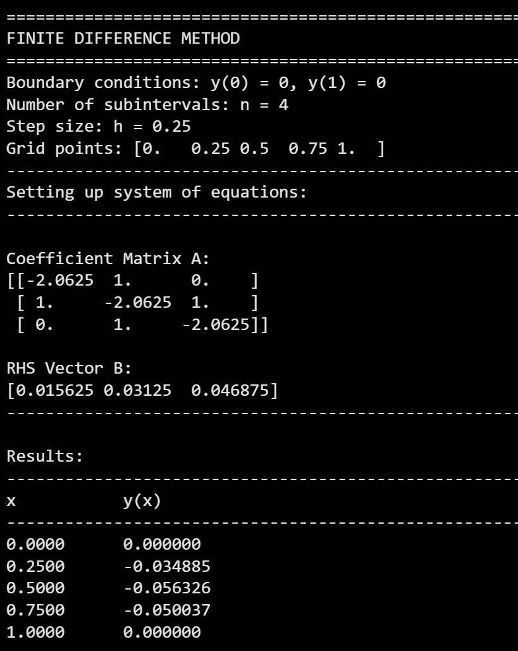
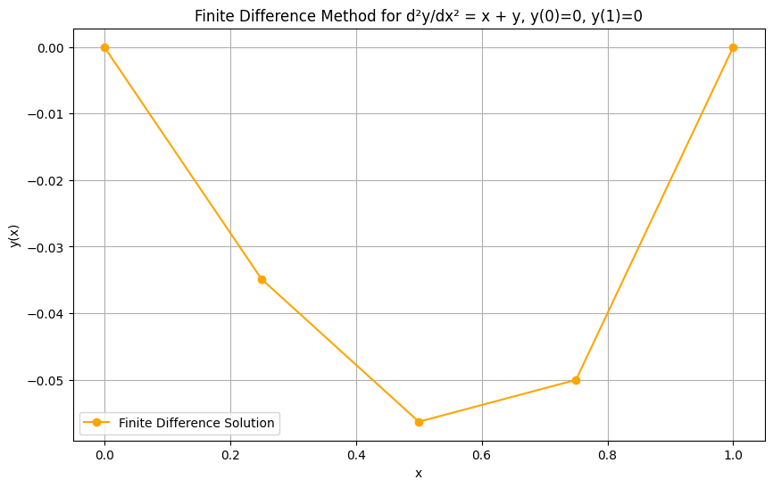

Solution of Partial Differential Equations
Prepared by: Er. Rubi Kumari Mahato

6.1 Introduction and Classification
Definition
A Partial Differential Equation (PDE) is an equation involving derivatives with respect to two or more independent variables.
Role in Engineering
PDEs model physical phenomena such as:
- Heat transfer
- Wave propagation
- Fluid flow
- Electromagnetic fields
- Stress distribution

ODE vs. PDE

Feature | ODE | PDE
Independent variables | One | Two or more
Derivatives | Ordinary derivatives | Partial derivatives
General solution contains | Arbitrary constants | Arbitrary functions
Example | $$\frac{dy}{dx}+y=0$$ | $$\frac{∂u}{∂t}=c^{2}\frac{∂^{2}u}{∂x^{2}}$$

Analytical vs. Numerical Solution

Analytical Solution | Numerical Solution
Exact solution | Approximate values
Limited to simple geometries | Works for complex geometries
Closed-form expression | Discrete grid points
Example: $u(x,t)=sin⁡(πx)e^{-π^{2}t}$ | Example: $U_{i,j+1}=\frac{1}{2}(U_{i-1,j}+U_{i+1,j})$

Standard Form of Second Order PDE
A general linear second-order PDE is:
$$Au_{xx}+Bu_{xy}+Cu_{yy}+Du_{x}+Eu_{y}+Fu=G$$
Classification
Based on the discriminant $Δ=B^{2}-4AC$:
Type | Condition | Characteristics | Examples
Elliptic | $$B^{2}-4AC<0$$ | Steady-state, boundary value problems | Laplace, Poisson
Parabolic | $$B^{2}-4AC=0$$ | Time-dependent diffusion, initial-boundary value problems | Heat equation
Hyperbolic | $$B^{2}-4AC>0$$ | Wave propagation, initial value problems | Wave equation
Physical Interpretation:
- Elliptic: No time dependence. Values depend on all boundaries. (Example: Temperature distribution in a plate)
- Parabolic: Time-dependent smoothing/diffusion. (Example: Cooling of a rod)
- Hyperbolic: Time-dependent wave-like behavior. (Example: Vibrating string)

6.2 Finite Difference Approximations of Partial Derivatives
Mesh Grid
We discretize the domain into a grid with:
- Spacing in $x$-direction: $Δx=h$
- Spacing in $y$- or $t$-direction: $Δy=k$ or $Δt=k$
- Grid point: $\left(x_{i},y_{j})=(ih,jk\right)$
- Function value: $u(x_{i},y_{j})≈U_{i,j}$
First Order Partial Derivatives
Type | Formula | Order of Accuracy
Forward difference | $$\frac{∂u}{∂x}≈\frac{U_{i+1,j}-U_{i,j}}{h}$$ | $$O(h)$$
Backward difference | $$\frac{∂u}{∂x}≈\frac{U_{i,j}-U_{i-1,j}}{h}$$ | $$O(h)$$
Central difference | $$\frac{∂u}{∂x}≈\frac{U_{i+1,j}-U_{i-1,j}}{2h}$$ | $$O(h^{2})$$

Second Order Partial Derivatives
Derivative | Finite Difference Formula
$$\frac{∂^{2}u}{∂x^{2}}$$ | $$\frac{U_{i+1,j}-2U_{i,j}+U_{i-1,j}}{h^{2}}$$
$$\frac{∂^{2}u}{∂y^{2}}$$ | $$\frac{U_{i,j+1}-2U_{i,j}+U_{i,j-1}}{k^{2}}$$
$$\frac{∂^{2}u}{∂x∂y}$$ | $$\frac{U_{i+1,j+1}-U_{i+1,j-1}-U_{i-1,j+1}+U_{i-1,j-1}}{4hk}$$

6.3 Solution of Elliptic Equations
Elliptic PDEs describe steady-state phenomena where the solution does not change with time.
6.3.1 Laplace Equation
The Laplace equation is the simplest elliptic PDE:
$$\frac{∂^{2}u}{∂x^{2}}+\frac{∂^{2}u}{∂y^{2}}=0$$
Physical applications:
- Steady-state temperature distribution
- Electrostatic potential
- Incompressible fluid flow potential
- Stress function in elasticity
Standard Five-Point Formula
Using central differences with $Δx=Δy=h$:
$$\frac{U_{i+1,j}-2U_{i,j}+U_{i-1,j}}{h^{2}}+\frac{U_{i,j+1}-2U_{i,j}+U_{i,j-1}}{h^{2}}=0$$
Simplifying:
$$U_{i+1,j}+U_{i-1,j}+U_{i,j+1}+U_{i,j-1}-4U_{i,j}=0$$
Therefore:
$$\boxed{U_{i,j}=\frac{1}{4}\left[U_{i-1,j} + U_{i+1,j} + U_{i,j+1} + U_{i,j-1}\right]}$$
Physical meaning: The value at any interior point is the average of its four neighboring points (left, right, above, below).
Diagonal Five-Point Formula
This formula uses diagonal neighbors:
$$\boxed{U_{i,j}=\frac{1}{4}\left[U_{i-1,j-1} + U_{i-1,j+1} + U_{i+1,j-1} + U_{i+1,j+1}\right]}$$
Note: Less accurate than the standard formula but useful for obtaining starting values in iterative methods.
Iterative Methods for Laplace Equation
Since interior points are coupled, we solve iteratively.
Jacobi's Method (Simultaneous Displacement):
$$U_{i,j}^{\left(n + 1\right)}=\frac{1}{4}\left[U_{i-1,j}^{\left(n\right)} + U_{i+1,j}^{\left(n\right)} + U_{i,j+1}^{\left(n\right)} + U_{i,j-1}^{\left(n\right)}\right]$$
- All new values computed from previous iteration's values
- Slower convergence
- Easy to parallelize
Gauss-Seidel Method (Successive Displacement):
$$U_{i,j}^{\left(n + 1\right)}=\frac{1}{4}\left[U_{i-1,j}^{\left(n + 1\right)} + U_{i+1,j}^{\left(n\right)} + U_{i,j+1}^{\left(n\right)} + U_{i,j-1}^{\left(n + 1\right)}\right]$$
- Uses latest available values immediately
- Converges approximately twice as fast as Jacobi
- More commonly used
Convergence Criterion:
Stop iterations when:
$$\underset{i,j}{max⁡}∣U_{i,j}^{\left(n + 1\right)}-U_{i,j}^{\left(n\right)}∣<ε$$
where $ε$ is a prescribed tolerance (e.g., 0.001).
Example: Iterative Solution of Laplace Equation
$$\begin{matrix}\text{Iteration} & U_{1} & U_{2} & U_{4} & U_{5} \\ 6 & 951 & 1016 & 1266 & 1146 \\ 7 & 946 & 1011 & 1260 & 1138 \\ 8 & 943 & 1057 & 1257 & 1134 \\ 9 & 941 & 1065 & 1255 & 1131 \\ 10 & 940 & 1003 & 1253 & 1129 \\ 11 & 939 & 1002 & 1252 & 1122 \\ 12 & 939 & 1001 & 1251 & 1126\end{matrix}$$
Difference between 11th and 12th iterations is negligible. Hence:
$$\boxed{U_{1}=939,U_{2}=1001,U_{4}=1251,U_{5}=1126}$$

6.3.2 Poisson Equation
The Poisson equation includes a source term $f(x,y)$:
$$\frac{∂^{2}u}{∂x^{2}}+\frac{∂^{2}u}{∂y^{2}}=f(x,y)$$
Physical applications:
- Heat conduction with heat sources
- Electrostatics with charge distribution
- Gravitational potential with mass distribution
Finite Difference Form
Using the same discretization:
$$\frac{U_{i+1,j}-2U_{i,j}+U_{i-1,j}}{h^{2}}+\frac{U_{i,j+1}-2U_{i,j}+U_{i,j-1}}{h^{2}}=f_{i,j}$$
Solving for $U_{i,j}$:
$$\boxed{U_{i,j}=\frac{1}{4}\left[U_{i-1,j}+U_{i+1,j}+U_{i,j+1}+U_{i,j-1}-h^{2}f_{i,j}\right]}$$
Note: If $f(x,y)=0$, Poisson reduces to Laplace.
Iterative Solution for Poisson
Jacobi:
$$U_{i,j}^{\left(n + 1\right)}=\frac{1}{4}\left[U_{i-1,j}^{\left(n\right)}+U_{i+1,j}^{\left(n\right)}+U_{i,j+1}^{\left(n\right)}+U_{i,j-1}^{\left(n\right)}-h^{2}f_{i,j}\right]$$
Gauss-Seidel:
$$U_{i,j}^{\left(n + 1\right)}=\frac{1}{4}\left[U_{i-1,j}^{\left(n + 1\right)}+U_{i+1,j}^{\left(n\right)}+U_{i,j+1}^{\left(n\right)}+U_{i,j-1}^{\left(n + 1\right)}-h^{2}f_{i,j}\right]$$

6.4 Solution of Parabolic and Hyperbolic Equations
6.4.1 One-Dimensional Heat Equation
The 1D heat equation is parabolic:
$$\frac{∂u}{∂t}=c^{2}\frac{∂^{2}u}{∂x^{2}} .....1$$where $c^{2}=k/ρ$ is the diffusivity of the substance (material).
Physical applications:
- Temperature distribution in a rod
- Diffusion of chemicals
- Option pricing in finance (Black-Scholes)
Schmidt Method (Explicit)
Schmidt Method considers a rectangular mesh in the $x$-$t$ plane with spacing $h$ along the $x$ direction and $k$ along time $t$ direction. Denoting a mesh point $\left(x,t)=(i,j\right)$ as simply $i,j$, we have:
$$\begin{matrix} & \frac{∂u}{∂t}≈\frac{u_{i,j+1}-u_{i,j}}{k} & & \text{(A)}\end{matrix} \\ \begin{matrix} & \frac{∂^{2}u}{∂x^{2}}≈\frac{u_{i-1,j}-2u_{i,j}+u_{i+1,j}}{h^{2}} & & \text{(B)}\end{matrix}$$
Substituting (A) and (B) into equation (1), we obtain:
$$U_{i,j+1}-U_{i,j}=kc^{2}\left[U_{i-1,j}-2U_{i,j}+U_{i+1,j}\right]$$
or,
$$\begin{matrix} & U_{i,j+1}=αU_{i-1,j}+(1-2α)U_{i,j}+αU_{i+1,j} & ..... & \text{2}\end{matrix}$$
where:
$$α=\frac{kc^{2}}{h^{2}}$$
is the mesh ratio parameter.
This formula enables us to determine the value of $u$ at the $\left(i,j+1\right)$-th mesh point in terms of the known function values at the points $x_{i-1}$, $x_{i}$, and $x_{i+1}$ at the instant $t_{j}$. It is a relation between the function values at the two levels $j$ and $j+1$ and is therefore called a 2-level formula.
In schematic form:
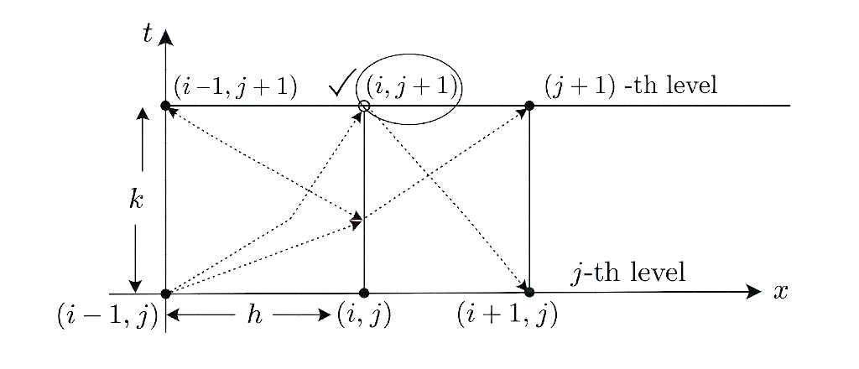
Figure: illustration of Bendre-Schmidt Heat Equation
Stability Condition: $0<α≤\frac{1}{2}$
Special Case: $α=\frac{1}{2}$
When $α=\frac{1}{2}$, the formula simplifies to:
$$\boxed{U_{i,j+1}=\frac{1}{2}\left(U_{i-1,j} + U_{i+1,j}\right)}$$
This is called the Dendra-Schmidt recurrence relation.
Observation: In particular when $α=\frac{1}{2}$, equation (2) reduces to:
$$\begin{matrix} & U_{i,j+1}=\frac{1}{2}\left(U_{i-1,j} + U_{i+1,j}\right) & .....3 & \end{matrix}$$
which shows that the value of $u$ at $x_{i}$ at time $t_{j+1}$ is the mean of the $u$-values at $x_{i-1}$ and $x_{i+1}$ at time $t_{j}$. This relation, known as the Dendra-Schmidt recurrence relation, gives the values of $u$ at the internal mesh point $O_{i}$ with the help of boundary conditions.
Interpretation: The future value at $x_{i}$ is the average of the current values at the neighboring points $x_{i-1}$ and $x_{i+1}$.
It is clear that formulas (2) and (3) have limited application because of the restriction on $α$. A formula which does not have any restriction on $α$ is that due to Crank and Nicolson, called the Crank-Nicolson formula for the one-dimensional heat equation.

Example 1: Schmidt Method
Problem:
Solve $\frac{∂u}{∂t}=\frac{∂^{2}u}{∂x^{2}}$ with:
Initial condition: $u(x,0)=sin⁡(πx)$, $0≤x≤1$
Boundary conditions: $u(0,t)=u(1,t)=0$
Take $h=\frac{1}{3}$, $k=\frac{1}{36}$
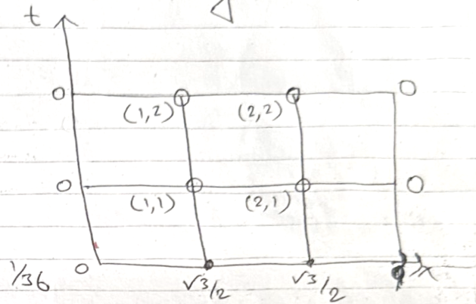
Solution:
Step 1: Identify parameters
Comparing with the standard heat equation:
$$\frac{∂u}{∂t}=c^{2}\frac{∂^{2}u}{∂x^{2}}$$
We get $c^{2}=1$.
Given: $h=\frac{1}{3}$, $k=\frac{1}{36}$
Step 2: Calculate mesh ratio parameter
$$α=\frac{c^{2}k}{h^{2}}=\frac{1×\frac{1}{36}}{{\left(\frac{1}{3}\right)}^{2}}=\frac{1/36}{1/9}=\frac{1}{4}$$
Step 3: Initial conditions
$$U_{1,0}=sin⁡\left(π ⋅ \frac{1}{3}\right)=sin⁡\left(\frac{π}{3}\right)=\frac{\sqrt{3}}{2}≈0.866 \\ U_{2,0}=sin⁡\left(π ⋅ \frac{2}{3}\right)=sin⁡\left(\frac{2π}{3}\right)=\frac{\sqrt{3}}{2}≈0.866$$
Boundary values: $U_{0,j}=0$ and $U_{3,j}=0$ for all $j$.
Step 4: Schmidt's explicit formula
The general formula:
$$U_{i,j+1}=αU_{i-1,j}+(1-2α)U_{i,j}+αU_{i+1,j}$$
Substituting $α=\frac{1}{4}$:
$$U_{i,j+1}=\frac{1}{4}U_{i-1,j}+\left(1 − \frac{1}{2}\right)U_{i,j}+\frac{1}{4}U_{i+1,j} \\ U_{i,j+1}=\frac{1}{4}\left[U_{i-1,j} + 2U_{i,j} + U_{i+1,j}\right]$$
Step 5: First level ($j=0→j=1$)
For $i=1$:
$$U_{1,1}=\frac{1}{4}\left[U_{0,0} + 2U_{1,0} + U_{2,0}\right]=\frac{1}{4}\left[0+2(0.866)+0.866\right]=\frac{1}{4}(2.598)=0.65$$
For $i=2$:
$$U_{2,1}=\frac{1}{4}\left[U_{1,0} + 2U_{2,0} + U_{3,0}\right]=\frac{1}{4}\left[0.866+2(0.866)+0\right]=\frac{1}{4}(2.598)=0.65$$
Step 6: Second level ($j=1→j=2$)
For $i=1$:
$$U_{1,2}=\frac{1}{4}\left[U_{0,1} + 2U_{1,1} + U_{2,1}\right]=\frac{1}{4}\left[0+2(0.65)+0.65\right]=\frac{1}{4}(1.95)=0.49$$
For $i=2$:
$$U_{2,2}=\frac{1}{4}\left[U_{1,1} + 2U_{2,1} + U_{3,1}\right]=\frac{1}{4}\left[0.65+2(0.65)+0\right]=\frac{1}{4}(1.95)=0.49$$
Answer:
$$\boxed{U_{1,1}=0.65,U_{2,1}=0.65,U_{1,2}=0.49,U_{2,2}=0.49}$$

Problem 2
Find the values of $u(x,t)$ satisfying the parabolic equation:
$$\frac{∂u}{∂t}=\frac{1}{4}\frac{∂^{2}u}{∂x^{2}}$$
with boundary conditions:
$$u(0,t)=0=u(8,t)$$
and initial condition:
$$u(x,0)=4x-\frac{1}{2}x^{2}$$
at the points $x=i$ ($i=0,1,2,…,7$) and $t=\frac{1}{8}j$ ($j=0,1,2,…,5$).

Solution
Step 1: Parameters
Here $c^{2}=4$, $h=1$, $K=\frac{1}{8}$
$$α=\frac{c^{2}K}{h^{2}}=\frac{4×\frac{1}{8}}{1}=\frac{1}{2}$$
Step 2: Bendre-Schmidt recurrence relation
Since $α=\frac{1}{2}$, the formula reduces to:
$$\begin{matrix} & U_{i,j+1}=\frac{1}{2}\left(U_{i-1,j} + U_{i+1,j}\right) & & \text{(1)}\end{matrix}$$
Boundary conditions: $U_{0,j}=0$ and $U_{8,j}=0$ for all $j$.
Step 3: Initial row ($j=0$)
$$U(x,0)=4x-\frac{x^{2}}{2} \\ \begin{matrix}U_{0,0} & =4(0)-\frac{0^{2}}{2}=0 \\ U_{1,0} & =4(1)-\frac{1^{2}}{2}=4-0.5=3.5 \\ U_{2,0} & =4(2)-\frac{2^{2}}{2}=8-2=6 \\ U_{3,0} & =4(3)-\frac{3^{2}}{2}=12-4.5=7.5 \\ U_{4,0} & =4(4)-\frac{4^{2}}{2}=16-8=8 \\ U_{5,0} & =4(5)-\frac{5^{2}}{2}=20-12.5=7.5 \\ U_{6,0} & =4(6)-\frac{6^{2}}{2}=24-18=6 \\ U_{7,0} & =4(7)-\frac{7^{2}}{2}=28-24.5=3.5 \\ U_{8,0} & =4(8)-\frac{8^{2}}{2}=32-32=0\end{matrix}$$
Step 4: First time level ($j=1$)
Using equation (1) with $j=0$:
$$\begin{matrix}U_{1,1} & =\frac{1}{2}(U_{0,0}+U_{2,0})=\frac{1}{2}(0+6)=3 \\ U_{2,1} & =\frac{1}{2}(U_{1,0}+U_{3,0})=\frac{1}{2}(3.5+7.5)=5.5 \\ U_{3,1} & =\frac{1}{2}(U_{2,0}+U_{4,0})=\frac{1}{2}(6+8)=7 \\ U_{4,1} & =\frac{1}{2}(U_{3,0}+U_{5,0})=\frac{1}{2}(7.5+7.5)=7.5 \\ U_{5,1} & =\frac{1}{2}(U_{4,0}+U_{6,0})=\frac{1}{2}(8+6)=7 \\ U_{6,1} & =\frac{1}{2}(U_{5,0}+U_{7,0})=\frac{1}{2}(7.5+3.5)=5.5 \\ U_{7,1} & =\frac{1}{2}(U_{6,0}+U_{8,0})=\frac{1}{2}(6+0)=3\end{matrix}$$
Step 5: Second time level ($j=2$)
Using equation (1) with $j=1$:
$$\begin{matrix}U_{1,2} & =\frac{1}{2}(U_{0,1}+U_{2,1})=\frac{1}{2}(0+5.5)=2.75 \\ U_{2,2} & =\frac{1}{2}(U_{1,1}+U_{3,1})=\frac{1}{2}(3+7)=5 \\ U_{3,2} & =\frac{1}{2}(U_{2,1}+U_{4,1})=\frac{1}{2}(5.5+7.5)=6.5 \\ U_{4,2} & =\frac{1}{2}(U_{3,1}+U_{5,1})=\frac{1}{2}(7+7)=7 \\ U_{5,2} & =\frac{1}{2}(U_{4,1}+U_{6,1})=\frac{1}{2}(7.5+5.5)=6.5 \\ U_{6,2} & =\frac{1}{2}(U_{5,1}+U_{7,1})=\frac{1}{2}(7+3)=5 \\ U_{7,2} & =\frac{1}{2}(U_{6,1}+U_{8,1})=\frac{1}{2}(5.5+0)=2.75\end{matrix}$$
Continue similarly for $j=3,4,5$.
Answer: The values form a symmetric pattern about the center $x=4$.

Crank-Nicolson Method (Implicit)For the heat equation:
$\frac{∂U}{∂t}=c^{2}\frac{∂^{2}U}{∂x^{2}}$
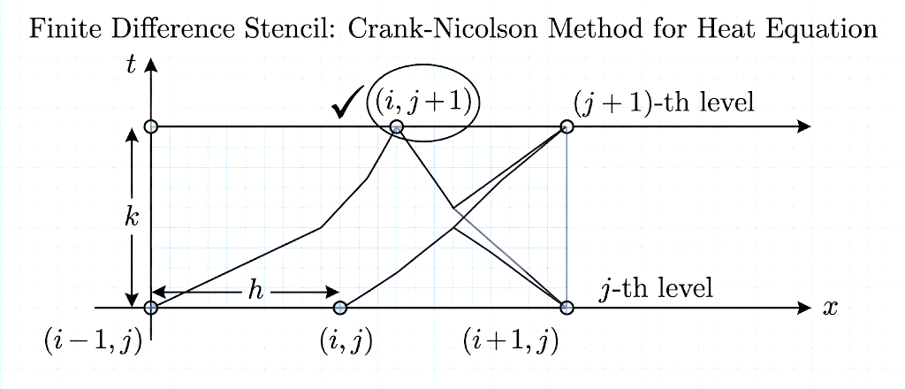
Figure: illustration of Crank Nicolson Heat Equation

The Crank-Nicolson formula is:
$$(2+2α)U_{i,j+1}=αU_{i-1,j}+αU_{i+1,j}+αU_{i-1,j+1}+αU_{i+1,j+1}+(2-2α)U_{i,j}$$
Solving for $U_{i,j+1}$:
$$U_{i,j+1}=\frac{1}{2(1+α)}\left[αU_{i+1,j}+αU_{i-1,j}+αU_{i+1,j+1}+αU_{i-1,j+1}+(1-α)2U_{i,j}\right]$$
In terms of A, B, C, D, E (neighboring points), we get:
$$U_{i,j+1}=\frac{1}{2(1+α)}\left[αD+αC+αB+αA+(1-α)2E\right]$$
Special Case: $α=1$
When $α=1$:
$$U_{i,j+1}=\frac{1}{4}\left[D + C + B + A\right] \\ ∴U_{i,j+1}=\frac{1}{4}\left[A + B + C + D\right]$$

Advantages over Schmidt method:
- Unconditionally stable (no restriction on $r$)
- Allows larger time steps
- Second-order accurate in both space and time
Disadvantage:
- Requires solving a tridiagonal system of equations at each time step
Solved Example 1: Crank-Nicolson Method
Problem
Solve:
$$\frac{∂^{2}u}{∂x^{2}}=\frac{∂u}{∂t}$$
subject to:
- $u(0,t)=0$, $u(1,t)=0$
- $u(x,0)=100x(1-x)$
Solution
Given equation: $\frac{∂^{2}u}{∂x^{2}}-\frac{∂u}{∂t}=0$
Comparing with $\frac{∂u}{∂t}=c^{2}\frac{∂^{2}u}{∂x^{2}}$, we get $c^{2}=1$.
Let $h=0.25$ (if not given, assume a reasonable value).
$$α=\frac{kc^{2}}{h^{2}}$$
Given $α=1$, so $k=h^{2}=0.0625$.
Initial condition values:
At $x=0.25$: $u=100×0.25×(1-0.25)=100×0.25×0.75=18.75$
At $x=0.50$: $u=100×0.50×0.50=25$
At $x=0.75$: $u=100×0.75×0.25=18.75$
Using Crank-Nicolson with $α=1$:
$$\begin{matrix} & U_{1}=\frac{1}{4}\left[0 + U_{2} + 25 + 0\right]⇒U_{1}=\frac{1}{4}(U_{2}+25) & & \text{(i)}\end{matrix} \\ \begin{matrix} & U_{2}=\frac{1}{4}\left[U_{1} + U_{3} + 18.75 + 18.75\right]⇒U_{2}=\frac{1}{4}(U_{1}+U_{3}+37.5) & & \text{(ii)}\end{matrix} \\ \begin{matrix} & U_{3}=\frac{1}{4}\left[U_{2} + 0 + 0 + 25\right]⇒U_{3}=\frac{1}{4}(U_{2}+25) & & \text{(iii)}\end{matrix}$$
Solving these three equations:
$$\boxed{U_{1}=9.82,U_{2}=14.28,U_{3}=9.82}$$

Solved Example 2:
Crank-Nicolson Problem
Solve:
$$\frac{∂^{2}U}{∂t∂x}=\frac{∂^{2}U}{∂x^{2}}$$
with conditions:
- $U(x,0)=0$
- $U(0,t)=0$
- $U(1,t)=200t$
Compute $U$ for one step in $t$ division.
Solution
Here $c^{2}=16$.
Take $h=0.25$ (standard assumption if not given).
$$α=\frac{kc^{2}}{h^{2}}$$
[Further computation would depend on choosing $k$ such that $α$ satisfies stability conditions.]

Iterative Solution for Laplace Equation
Iteration Results
$$\begin{matrix}\text{Iteration} & U_{1} & U_{2} & U_{3} & U_{4} \\ 6 & 951 & 1016 & 1266 & 1146 \\ 7 & 946 & 1011 & 1260 & 1138 \\ 8 & 943 & 1007 & 1257 & 1134 \\ 9 & 941 & 1005 & 1255 & 1131 \\ 10 & 940 & 1003 & 1253 & 1129 \\ 11 & 939 & 1002 & 1252 & 1128 \\ 12 & 939 & 1001 & 1251 & 1126\end{matrix}$$
Thus there is negligible difference between the values obtained in the 11th and 12th iterations.
Hence:
$$\boxed{U_{1}=939,U_{2}=1001,U_{3}=1251,U_{4}=1126}$$

Initial Values for Laplace Problem
To obtain initial values for interior points $u_{1},u_{2},u_{3},u_{4}$, assume $u_{4}=0$:
$$u_{1}=\frac{1}{4}(1000+0+1000+2000)=1000 \\ u_{2}=\frac{1}{4}(1000+5000+1000+0)=625 \\ u_{3}=\frac{1}{4}(2000+0+1000+500)=375 \\ u_{4}=\frac{1}{4}(375+0+625+0)=250$$

Comparison of Methods
Feature | Schmidt (Explicit) | Crank-Nicolson (Implicit)
Stability | Conditional ($r≤1/2$) | Unconditional
Time step restriction | Severe | None
Computation per step | Fast (explicit formula) | Slower (solve system)
Accuracy | First order in time | Second order in time
Implementation | Simple | More complex

6.4.2 Wave Equation
The 1D wave equation is hyperbolic:
$$\frac{∂^{2}u}{∂t^{2}}=c^{2}\frac{∂^{2}u}{∂x^{2}}$$
Physical applications:
- Vibrating string
- Sound waves
- Electromagnetic waves
- Seismic waves
Finite Difference Form
Using central differences for both $x$ and $t$:
$$\frac{U_{i,j+1}-2U_{i,j}+U_{i,j-1}}{k^{2}}=c^{2}\frac{U_{i+1,j}-2U_{i,j}+U_{i-1,j}}{h^{2}}$$
Let $r=\frac{ck}{h}$ (Courant number). Solving for $U_{i,j+1}$:
$$\boxed{U_{i,j+1}=2(1-r^{2})U_{i,j}+r^{2}(U_{i+1,j}+U_{i-1,j})-U_{i,j-1}}$$
Stability Condition (CFL Condition)
For convergence:
$$\boxed{r=\frac{ck}{h}≤1}$$
This is the Courant-Friedrichs-Lewy (CFL) condition.
Interpretation: The numerical wave speed must be at least as fast as the physical wave speed.
Special Case: $r=1$
When $r=1$, the formula simplifies:
$$U_{i,j+1}=U_{i+1,j}+U_{i-1,j}-U_{i,j-1}$$
Initial Conditions
For the wave equation, we need two initial conditions:
- Initial displacement: $u(x,0)=f(x)$
- Initial velocity: $\frac{∂u}{∂t}(x,0)=g(x)$
The first time level ($j=1$) can be computed using:
$$U_{i,1}=U_{i,0}+kg(x_{i})+\frac{r^{2}}{2}(U_{i+1,0}-2U_{i,0}+U_{i-1,0})$$

